**IST302**

**SPRING 2021**

**Final Project Report on Sales Transaction Application**

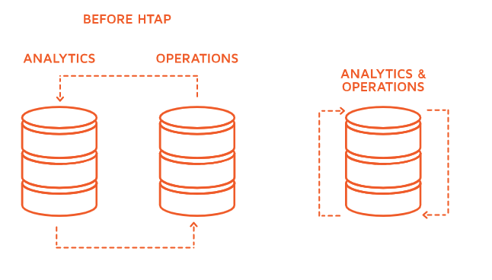

IT Solution Team

Group 5: 2021DBSpring_FP_Distrbuted_DB

Jarvis Bigger/​​ Miles von Herrmann​​ /Chiaching Hsieh

***Content***

**Section 1 - Business Understanding ----------------------------------------------- 2**

**Section 2 - Data Understanding ----------------------------------------------- 4**

**Section 3 - Conceptual Design ----------------------------------------------- 9**

**Section 4 - Security Requirements ----------------------------------------------- 10**

**Section 5 - Logic design ----------------------------------------------- 16**

**Section 6: Physical Design ----------------------------------------------- 21**

**Section 7: Database Implementation ----------------------------------------------- 26**

**Section 8: Conclusion ----------------------------------------------- 39**

**Section 1 - Business Understanding**

**Overview of Sales Transaction Applications**

A sales transaction is an exchange of a product or service in exchange for some money or other compensation. A transaction processing system (TPS) is an information processing system for business transactions involving the collection, modification, and retrieval of all transaction data.

The Retail industry is steadily evolving its capabilities given the nature of technology today. This industry has billions of dollars of valuation. From big names like Amazon, the point-of-sale transaction system in-store and online databases are used to expand data to users easily.

Structured Query Language (SQL) is a programming language used to let people manipulate and access databases. SQL can address problems quickly to find data with common characteristics. Dealing with a sales transaction system, there is a number of data points that are accumulated over time. The orders are the most impactful items within this system because they comprise all the enriched sales data, sales channels, customer information, locations, promotions, and other parameters to help map data together to come to a common conclusion.

We will dive into ways we plan on keeping the integrity of the data secure and separate with user views on different areas of the data. There will be specific constraints to deal with the integrity of the system. Using values such as foreign keys when dealing with referential integrity and improving performance with certain indexes.

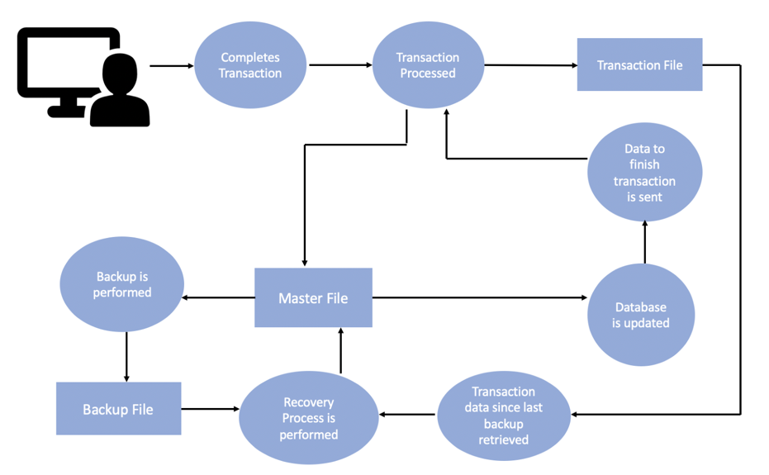

**List of users for the sales transaction system**​***:***

1. *Data admin*
2. *Sales Representatives*
3. *Manager/CEO/Executive*
4. *Sales Analysts*
5. *Accountant*
6. *Shipping Department personnel*
7. *Purchase*
8. *Marketing*
9. *Customer relations*

**Current Problems:**

1. **Database is too slow**
2. **Database has too many inconsistencies**
3. **No reports for business user**

***We are going to focus on fewer users and be specific about what access to the data they are going to have.***

|  |  |
| --- | --- |
| User | Access Area |
| Marketing Managers | Point of Sale, Shipping, Promotions |
| Sales Associate | Shipping, Point of Sale |
| Product Managers | Sale , Customer, Shipping |

**Marketing Managers** will have access to the Channels, Products, Customer information, Promotions, and Orders.     
    
**Sales Associate workers** will have access to the Orders, Customer Information, with limited view on some areas around promotions when needed.

**Product Managers** will have access to the sale, Customer, and products information which can help to understand the trends of markets and improve products quality and

**Section 2 - Data Understanding**

|  |  |  |  |  |  |  |
| --- | --- | --- | --- | --- | --- | --- |
| **Table Name** | **Columns** | **Description** | **Data Type** | **Null** | **C** | **Justification** |
| LI_CHANNELS | CHANNEL_ID | Unique ID associated with Channel | PK,CHAR(1) | Not null | Y | Integer (10) |
| CHANNEL_DESC | Descript channel type | VARCHAR(20) | Not null |  |  |
| CHANNEL_CLASS | Descript channel sale method: Direct, Indirect, and other. | VARCHAR(20) | null |  |  |
| CHANNEL_TOTAL |  | VARCHAR(13) | null | Y | Remove, Useless data |
| LI_CUSTOMERS_EXT | **CUST_ID** | Unique ID associated with customer | PK, DECIMAL(22,0) | Not null | Y | Integer (10) |
| CUST_GENDER | Gender of customer  (M/F) | CHAR(1) | null |  |  |
| CUST_YEAR_OF_BIRTH | Birth year of customer | DECIMAL(22,0) | null | Y | Integer (4) |
| CUST_MARITAL_STATUS | Marital status of customer  (single/married/divorced) | VARCHAR(20) | null |  |  |
| CUST_INCOME_LEVEL | Income level of customer.  12 income levels(A to L) listed – beginning at A(below $30,000, from $30,000) upwards income levels are broken into 11 distinct buckets which each have a range of $19,999 | VARCHAR(30) | null |  |  |
| CUST_CREDIT_LIMIT | Credit limit of customer | DECIMAL(20,0) | Not null | Y | Integer (20) |
| LI_CUSTOMERS_INTX | **CUST_ID** | Unique ID associated with customer | DECIMAL(22,0) | Not null | Y | Integer (20) |
| CUST_FIRST_NAME | First name of customer | VARCHAR(20) | Not null |  |  |
| CUST_LAST_NAME | Last name of customer | VARCHAR(40) | Not null |  |  |
| CUST_GENDER | Gender of customer | CHAR(1) | null |  |  |
| CUST_MAIN_PHONE_NUMBER | Main phone number of customers | VARCHAR(25) | null |  |  |
| CUST_EMAIL | Email address belonging to customer | VARCHAR(30) | null |  |  |
| CUST_STREET_ADDRESS | Street address of customer | VARCHAR(40) | Not null |  |  |
| CUST_POSTAL_CODE | Postal code associated with customer’s address | VARCHAR(10) | Not null |  |  |
| CUST_CITY | City where customer is living | VARCHAR(30) | Not null |  |  |
| CUST_STATE_PROVINCE | State or international province where customer is living | VARCHAR(40) | null |  |  |
| C.COUNTRY_ID | Unique ID associated with the country in which customer is living | CHAR(5) | null | Y | Integer (10) |
| CUST_TOTAL |  | VARCHAR(14) | null | Y | Remove, Useless data |
| COUNTRY_NAME | Country in which customer is living | VARCHAR(50) | null | Y | Create new table COUNTRY |
| COUNTRY_SUBREGION | Specific region within continent in which customer is living | VARCHAR(30) | null | Y | Create new table COUNTRY |
| COUNTRY_REGION | Continent in which customer is living | VARCHAR(20) | null | Y | Create new table COUNTRY |
| COUNTRY_TOTAL |  | VARCHAR(11) | null | Y | Remove, Useless data |
| LI_PRODUCTS | SUPPLIER_ID | Unique ID associated with Supplier (All:1) | DECIMAL(22,0) | Not null | Y | Integer (22) |
| PROD_STATUS | Product status  (All: STATUS) | VARCHAR(20) | Not null |  |  |
| PROD_LIST_PRICE | Products price | DECIMAL(22,0) | Not null |  |  |
| PROD_MIN_PRICE | Same like PROD_LIST_PRICE | DECIMAL(22,0) | Not null |  |  |
| PROD_TOTAL | ?? All TOTAL | VARCHAR(13) | null | Y | Remove, Useless data |
| **PROD_ID** | Unique ID associated with product | PK, DECIMAL(22,0) | Not null | Y | Integer (10) |
| PROD_NAME | Name of product | VARCHAR(50) | Not null |  |  |
| PROD_DESC | Description of product – contains the same data as PROD_NAME | VARCHAR(4000) | Not null |  |  |
| PROD_SUBCATEGORY | Subcategory of product, defines product type | VARCHAR(50) | Not null |  |  |
| PROD_SUBCAT_DESC | Description of the subcategory – contains the same data as PROD_SUBCATEGORY | VARCHAR(2000) | Not null |  |  |
| PROD_CATEGORY | Category of product,  like PROD_SUBCATEGORY but defines product type more broadly | VARCHAR(50) | Not null |  |  |
| PROD_CAT_DESC | Description of the category – contains the same data as PROD_CATEGORY  Only PROD_ID 13 different | VARCHAR(2000) | Not null |  |  |
| PROD_WEIGHT_CLASS | Weight class of product  From 1 to 4  Only PROD_ID 139 is 4 | DECIMAL(22,0) | null |  |  |
| PROD_UNIT_OF_MEASURE | Each product must be stocked in a single unit of measure.  All products are U | VARCHAR(20) | null |  |  |
| PROD_PACK_SIZE | Products packaged size  All products are P | VARCHAR(30) | null |  |  |
| LI_PROMOTIONS | **PROMO_ID** | Unique ID associated with promotion | DECIMAL(22,0) | Not null | Y | Integer (10) |
| PROMO_NAME | Name of promotion | VARCHAR(30) | Not null |  |  |
| PROMO_SUBCATEGORY | Subcategory of product, defines promotion type | VARCHAR(30) | Not null |  |  |
| PROMO_CATEGORY | Category of promotion,  like PROD_SUBCATEGORY but defines product type more broadly | VARCHAR(30) | Not null |  |  |
| PROMO_COST | The cost of promotion | DECIMAL(22,0) | Not null | Y | Integer (10) |
| PROMO_BEGIN_DATE | The Date of promotion start | DATE | Not null |  |  |
| PROMO_END_DATE | The Date of promotion end | DATE | Not null |  |  |
| PROMO_TOTAL | ?? All Promotion TOTAL | VARCHAR(15) | Not null | Y | Remove, Useless data |
| LI_SALES_12_13  (2012&2013) | **SALESTRANS_ID** | Unique ID associated with sales transaction | PK, DECIMAL(22,0) | Not null | Y | Integer (10) |
| PROD_ID | Unique ID associated with product | VARCHAR(255) | null | Y | Integer (10) |
| CUST_ID | Unique ID associated with customer | VARCHAR(255) | null | Y | Integer (10) |
| CHANNEL_ID | Unique ID associated with Channel | VARCHAR(255) | null | Y | Integer (10) |
| PROMO_ID | Unique ID associated with promotion | VARCHAR(255) | null | Y | Integer (10) |
| SALE_DATE | Date of sale | DATE | null |  |  |
| SHIPPING_DATE | Date of shipping | DATE | null |  |  |
| PAYMENT_DATE | Date of payment | DATE | null |  |  |
| QUANTITY_SOLD | the volume or quantity of products sold | DECIMAL(22,0) | null |  |  |
| AMOUNT_SOLD | the total amount which the Vendors have received | DECIMAL(22,0) | null |  |  |
| UNIT_PRICE | Each transaction price | DECIMAL(22,0) | null |  |  |
| LI_SALES_14  (2014) | **SALESTRANS_ID** | Unique ID associated with sales transaction | PK, DECIMAL(22,0) | Not null | Y | Joint with LI_SALES_12_13 |
| PROD_ID | Unique ID associated with product | DECIMAL(22,0) | null | Y | Joint with LI_SALES_12_13 |
| CUST_ID | Unique ID associated with customer | DECIMAL(22,0) | null | Y | Joint with LI_SALES_12_13 |
| CHANNEL_ID, | Unique ID associated with Channel | DECIMAL(22,0) | null | Y | Joint with LI_SALES_12_13 |
| PROMO_ID | Unique ID associated with promotion | DECIMAL(22,0) | null | Y | Joint with LI_SALES_12_13 |
| SALE_DATE | Date of sale | DATE | null | Y | Joint with LI_SALES_12_13 |
| SHIPPING_DATE | Date of shipping | DATE | null | Y | Joint with LI_SALES_12_13 |
| PAYMENT_DATE | Date of payment | DATE | null | Y | Joint with LI_SALES_12_13 |
| QUANTITY_SOLD | the volume or quantity of products sold | DECIMAL(22,0) | null | Y | Joint with LI_SALES_12_13 |
| AMOUNT_SOLD | the total amount which the Vendors have received | DECIMAL(22,0) | null | Y | Joint with LI_SALES_12_13 |
| UNIT_PRICE | Each transaction price | DECIMAL(22,0) | null | Y | Joint with LI_SALES_12_13 |

**DATA Inconsistencies**

|  |  |  |
| --- | --- | --- |
|  | inconsistencies | Constraints |
| CUST_INCOME_LEVEL | Income level of customer.  12 income levels (A to L) listed – beginning at A (below $30,000, from $30,000) upwards income levels are broken into 11 distinct buckets which each have a range of $19,999 | Make view that the income level will show A-L but not numbers |
| CUST_GENDER | Gender of customer (Male/Female/Others) | Domain constraint on CUST_GENDER -- allow only M/F/O (male, female, other) |
| CUST_MARITAL_STATUS | Not all the data is filled out for all CUST_ID  Values are “married, single, divorced” |  |
| PROD_UNIT_OF_MEASURE | All values for “U” and not a unit of measure | Remove the column |
| PROD_WEIGHT_CLASS | All values equal “1” and makes no sense | Remove the column |
| PROD_PACK_SIZE | All values are “P” and makes no sense | Remove the column |
| PROD_STATUS | All values are listed as “STATUS” | Remove the column |
| SUPPLIER_ID | All values equal “1”, implying that the supplier is the same for all products, supplier ID values should be different because there is likely more than one supplier |  |
| PROD_DESC | Values from the two fields are identical to one another, we should consider removing one of the two fields |  |
| CHANNEL_TOTAL | All values include “Channel Total” string and not a numeric total | Remove the column |
| PROMO_TOTAL | All values include “Promotion total” string and not a numeric total. | Remove the column |
| COUNTRY_TOTAL | All values include “World total” string and not a numeric total. | Remove the column |
| CUST_STATE_PROVINCE | Some values are spelled all the way out while other values are abbreviated. |  |
| CUST_TOTAL | All values include “Customer total” string and not a numeric total. | Remove the column |

**Functional Dependencies**

|  |  |  |
| --- | --- | --- |
| **Table Name** | **Functional Dependency** | **Justification** |
| **LI_CHANNELS** | CHANNEL_ID ---> CHANNEL_DESC | If you know the ID of the channel, then you are able to determine what type it is |
| **LI_CUSTOMERS_EXT** | CUST_ID ---> CUST_GENDER, CUST_YEAR_OF_BIRTH, CUST_MARITAL_STATUS, CUST_INCOME_LEVEL, CUST_CREDIT_LIMIT | If you know the ID of the customer, then you are able to identify high level demographic characteristics associated with that customer |
| **LI_CUSTOMERS_INTX** | CUST_ID ---> ,CUST_FIRST_NAME, CUST_LAST_NAME | If you know the ID of the customer, then you are able to determine that customer’s full name |
| CUST_FIRST_NAME, CUST_LAST_NAME ---> CUST_MAIN_PHONE_NUMBER, CUST_EMAIL | The combination of a customer’s first and last name determine their main phone number and email, because no two individuals will have the same phone number and email |
| CUST_POSTAL_CODE ---> CUST_CITY, CUST_STATE_PROVINCE, COUNTRY_NAME | If we know the customer’s postal code, then we can determine the city the customer’s city, one or more zip codes are associated with a particular city |
| CUST_CITY ---> CUST_STATE_PROVINCE | The customer’s city determines what state or province they live in, due to the fact that a specific city only exists in one state or province |
| CUST_STATE_PROVINCE ---> COUNTRY_NAME | If we know the state/province of the customer then we are able to determine what country the customer lives in |
| COUNTRY_ID ---> COUNTRY_NAME | If we know the ID of a specific country then we are able to determine that country’s name, each ID is unique to exactly one country name |
| COUNTRTY_SUBREGION ---> COUNTRY_REGION | The specification of where a country exists within a certain region tells us what larger region the country is located in |
| **LI_PRODUCTS** | PROD_ID ---> PROD_NAME | If we know the ID of a product then we are able to determine what specific name is linked with that ID, each ID specifies a different product name |
| PROD_SUBCATEGORY ---> PROD_CATEGORY | The specification of a product’s subcategory tells us what larger category |
| **LI_PROMOTIONS** | PROMO_ID ---> PROMO_NAME | If we know the ID of a specific promotion then we are able to determine that promotion’s name, each ID is unique to exactly one promotion name |
| **LI_SALES_12_13**  **(2012&2013)** | SALESTRANSID ---> PROD_ID, CUST_ID, CHANNEL_ID, PROMO_ID | If we know the ID of the Sales transaction then we are able to obtain information from any of the other major tables within the database |
| **LI_SALES_14**  **(2014)** | SALESTRANSID ---> PROD_ID, CUST_ID, CHANNEL_ID, PROMO_ID | If we know the ID of the Sales transaction then we are able to obtain information from any of the other major tables within the database |

**Section 3 - Conceptual Data Modeling**

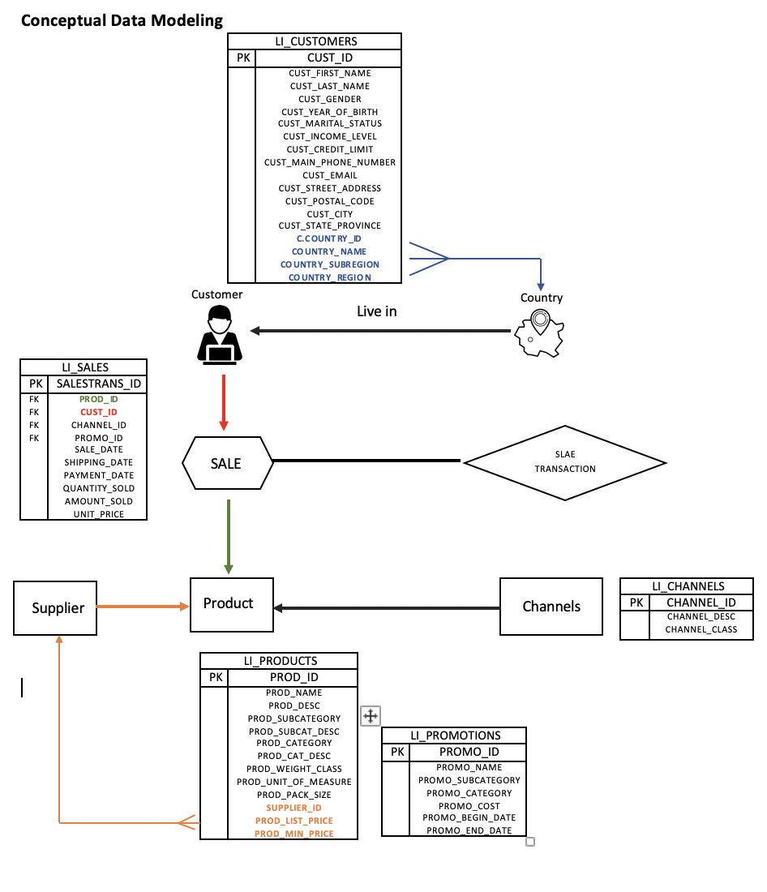

**Section 4 - Security Requirements**

|  |  |  |  |  |
| --- | --- | --- | --- | --- |
| User | Access Area/Business View | | | |
|  | **BV01**  (Customer) | **BV02**  (PROD, CUST, SALE) | **BV03**  (PROD, SALE, CUST) | **BV04**  (PROD, SALE, CUST) |
| Marketing  managers | **SELECT,** |  |  |  |
| Sales Associate |  | **SELECT, UPDATE** |  |  |
| Product  managers |  |  | **SELECT** | **SELECT** |

**1. Marketing managers:**

Some common responsibilities for Marketing Managers include evaluating and enhancing marketing and pricing strategies within the company. Individuals within this role also are tasked with analyzing trends in what products are successful in the market and preparing forecasts of what will be popular with customers in the future. Additionally, marketing managers are in charge of managing the marketing department’s budget, and overseeing branding, advertising, and promotional campaigns.

The Marketing Manager will need to be able to view product and promotion information, and conduct analysis on prices within specific product categories, the current promotional offers that are available to customers, and the amount and quantity sold of specific products. The Marketing Manager can calculate the average price of products within a specific product category:

CAST(AVG(P.PROD_LIST_PRICE) AS DECIMAL (8,2)) AS AVERAGE_PRODUCT_PRICE

Marketing managers can use these averages to identify what types of products might be sought after by certain income groups.

The Marketing Manager can also calculate averages for amount and quantity sold of different products, to analyze trends in what products have been successful with customers.

CAST(AVG(S.QUANTITY_SOLD) AS DECIMAL (8,2)),

CAST(AVG(S.AMOUNT_SOLD) AS DECIMAL (8,2))

Marketing managers can use these averages to create forecasts of what products will be successful with customers in the future, and can create projections of expected sale quantities.

Values relevant to this view are PROD_ID, PROD_NAME, PROD_LIST_PRICE, PROD_SUBCATEGORY, PROD_CATEGORY, PROMO_ID, PROMO_NAME, PROMO_SUBCATEGORY, PROMO_CATEGORY, PROMO_COST, PROMO_BEGIN_DATE, PROMO_END_DATE, QUANTITY_SOLD, AMOUNT_SOLD.

**2. Sales Associate:**

Some common responsibilities for Sales Associates include ensuring elevated levels of customer satisfaction through excellent sales service. Assess customers' needs and help and information on product features. Welcome customers to the store and answer their queries. Follow and achieve department's sales goals on a monthly, quarterly, and yearly basis. The Point-of-sale is the main system that encapsulates most of the data aggregated throughout the business. The Sales associate will quickly need to get customer information when processing an order to help populate all relevant information associated with the customer's order. Values that would be relevant to this view is PROD_ID, PROD_NAME, PROD_LIST_PRICE, PROD_CATEGORY, CUST_ID, CUST_FIRST_NAME, CUST_LAST_NAME, CUST_MAIN_PHONE_NUMBER, CUST_EMAIL, ZIP_CODE, AMOUNT_SOLD, QUANTITY_SOLD, & PAYMENT_DATE.    
   
The Sales Associate can calculate the discount (CAST(P.PROD_LIST_PRICE-(S.AMOUNT_SOLD/S.QUANTITY_SOLD) AS DECIMAL(8,2)) AS DISCOUNT_PRICE_1,

CAST(((S.AMOUNT_SOLD/S.QUANTITY_SOLD)*100)/P.PROD_LIST_PRICE AS DECIMAL(8,2)) AS

DISCOUNT_RATE_2, DATEDIFF (DAY, S.SALE_DATE, S.PAYMENT_DATE) AS DAYS_TO_PAY_D). Sales Associate’s can return the sale date and payment date to the customers while letting customers know the best price to pay overtime. Customers want options when they are at the table and being able to make the best decision based on their finances at the time.

The second view gives Sales Associates the correct parameters to detail out the shipping details to the customer. The data that aggregates within this view include is CUST_ID, CUST_FIRST_NAME, CUST_LAST_NAME, CUST_STREET_ADDRESS, CUST_CITY, CUST_POSTAL_CODE, COUNTRY_ID, COUNTRY_SUBREGION, COUNTRY_REGION, SALESTRANS_ID, PROD_ID, PROD_NAME, PROD_LIST_PRICE, PAYMENT_DATE, SALE_DATE, SHIPPING_DATE, QUANTITY_SOLD, AMOUNT_SOLD, UNIT_PRICE, PROMO_ID, PROMO_NAME, PROMO_SUBCATEGORY, & PROMO_TOTAL.   
   
Customers want to know where their orders are. Associates will be able to aggregate dates and even discounts when it comes to products and orders (CAST(P.PROD_LIST_PRICE-(S.AMOUNT_SOLD/S.QUANTITY_SOLD) AS DECIMAL(8,2)) AS DISCOUNT_PRICE_1,

CAST(((S.AMOUNT_SOLD/S.QUANTITY_SOLD)*100)/P.PROD_LIST_PRICE AS DECIMAL(8,2)) AS

DISCOUNT_RATE_2, DATEDIFF (DAY, S.SALE_DATE, S.PAYMENT_DATE) AS DAYS_TO_PAY_D

Associates will also be to see a queue of orders and ship accordingly given the day that it was purchased. They will need to see parameters like addresses, orders, and promotions, but not be allowed to see items like income.

**3. Product managers:**

Product managers focus on the product quality, quantity, shipping environment, amount sold of each product, and consumer response of products. At the same time, Product managers improve the product by review the customer satisfaction. Understanding the customer satisfaction means that different generation, different country and culture, or different income level can affect customer purchase willing, and make adjustment to improve or adapt customer demand. Except PRODUCTS table, Product managers need to view SALE_DATE, SHIPPING_DATE, PAYMENT_DATE, QUANTITY_SOLD, AMOUNT_SOLD, CUST_GENDER, CUST_YEAR_OF_BIRTH, CUST_MARITAL_STATUS, CUST_INCOME_LEVEL, COUNTRY_NAME, COUNTRY_SUBREGION, and COUNTER_REGION.

The Product managers can calculate each product sold of different gender or country.

(CAST SUM(QUANTITY_SOLD) WHERE PRO_NAME =’’ AND CUST_GENDER = ‘Female’) AS TOTAL_SOLD_IN_FEMALE,

CAST SUM(QUANTITY_SOLD) WHERE PRO_NAME =’’ AND COUNTRY_REGION = ‘Northern America’) ASTOTAL_SOLD_IN_ Northern America. Product managers can use the calculate view to understand customer respond and demand to improve the product and Strengthen market competition.

The other view for product managers is to understand market trends, and compete with the competitor.

(CAST SUM(QUANTITY_SOLD) WHERE PRO_CATEGORY =’CAMERA’) AS TOTAL_SOLD_CAMERA,

(CAST SUM(QUANTITY_SOLD) WHERE PRO_CATEGORY =’CAMERA’ AND COUNTRY_REGION = ‘Northern America’) AS TOTAL_SOLD_CAMERA_ Northern America,

Managers not only need to analysis the product inside the company, but also need to consider the market trends in different country and analysis data to compete with other companies.

Although, product managers need to focus on customer respond but not be allowed to see customer detail information like CUST_NAME, CUST MARITAL_STATUS, CUST CREDIT_LIMIT, or CUST STREET_ADDRESS etc.

Moreover, product managers can see the promotion data like PROMO_NAME, PROMO_CATEGORY, or PROMO_DATE but not be allowed to update or delete and not be allowed to see the PROMO_COST.

**SQL Query:**

**-Marketing Manager**

This view gives Marketing Managers the necessary information to get a clear picture of the products within the company’s inventory, and the promotional offers that are available to customers. This view also allows Marketing Managers to analyze past trends regarding which products have been successful, and helps them forecast future trends for specific products.

**View BV01**

SELECT

P.PROD_ID, P.PROD_NAME, P.PROD_LIST_PRICE, P.PROD_SUBCATEGORY, P.PROD_CATEGORY, PR.PROMO_ID, PR.PROMO_NAME, PR.PROMO_SUBCATEGORY, PR.PROMO_CATEGORY, PR.PROMO_COST, PR.PROMO_BEGIN_DATE, PR.PROMO_END_DATE, S.QUANTITY_SOLD, S.AMOUNT_SOLD,

CAST(AVG(P.PROD_LIST_PRICE) AS DECIMAL (8,2)) AS AVERAGE_PRODUCT_PRICE,

CAST(AVG(S.QUANTITY_SOLD) AS DECIMAL (8,2)) AS AVERAGE_QUANTITY_SOLD,

CAST(AVG(S.AMOUNT_SOLD) AS DECIMAL (8,2)) AS AVERAGE_AMOUNT_SOLD

FROM

LI_PRODUCTS P, LI_PROMOTIONS PR, LI_SALES_12_13_14 S

WHERE

S.PROD_ID = P.PROD_ID AND S.PROMO_ID = PR.PROMO_ID

GROUP BY

P.PROD_ID, P.PROD_NAME, P.PROD_LIST_PRICE, P.PROD_SUBCATEGORY, P.PROD_CATEGORY, PR.PROMO_ID, PR.PROMO_NAME, PR.PROMO_SUBCATEGORY, PR.PROMO_CATEGORY, PR.PROMO_COST, PR.PROMO_BEGIN_DATE, PR.PROMO_END_DATE, S.QUANTITY_SOLD, S.AMOUNT_SOLD,

CAST(AVG(P.PROD_LIST_PRICE) AS DECIMAL (8,2),

CAST(AVG(S.QUANTITY_SOLD) AS DECIMAL (8,2)),

CAST(AVG(S.AMOUNT_SOLD) AS DECIMAL (8,2))

ORDER BY

P.PROD_ID DESC, PR.PROMO_ID DESC

**-Sales Associate**

The second view gives Sales Associates the correct parameters to detail out the shipping details to the customer. The data that aggregates within this view include is CUST_ID, CUST_FIRST_NAME, CUST_LAST_NAME, CUST_STREET_ADDRESS, CUST_CITY, CUST_POSTAL_CODE, COUNTRY_ID, COUNTRY_SUBREGION, COUNTRY_REGION, SALESTRANS_ID, PROD_ID, PROD_NAME, PROD_LIST_PRICE, PAYMENT_DATE, SALE_DATE, SHIPPING_DATE, QUANTITY_SOLD, AMOUNT_SOLD, UNIT_PRICE, PROMO_ID, PROMO_NAME, PROMO_SUBCATEGORY, & PROMO_TOTAL.

Customers want to know where their orders are. Associates will be able to aggregate dates and even discounts when it comes to products (CAST(P.PROD_LIST_PRICE-(S.AMOUNT_SOLD/S.QUANTITY_SOLD) AS DECIMAL(8,2)) AS DISCOUNT_PRICE_1,

CAST(((S.AMOUNT_SOLD/S.QUANTITY_SOLD)*100)/P.PROD_LIST_PRICE AS DECIMAL(8,2)) AS

DISCOUNT_RATE_2, DATEDIFF (DAY, S.SALE_DATE, S.PAYMENT_DATE) AS DAYS_TO_PAY_D

Associates will also be to see a queue of orders and ship accordingly given the day that it was purchased. They will need to see parameters like addresses, orders, and promotions, but not be allowed to see items like income.   
**View BV02**  
   
SELECT

CI.CUST_ID, CI.CUST_FIRST_NAME+' '+CI.CUST_LAST_NAME AS FULL_NAME, CI.CUST_MAIN_PHONE_NUMBER,

CI.CUST_EMAIL, CI.CUST_POSTAL_CODE, P.PROD_ID AS PROD_ID_NUM, P.PROD_NAME, P.PROD_CATEGORY,

CAST(P.PROD_LIST_PRICE-(S.AMOUNT_SOLD/S.QUANTITY_SOLD) AS DECIMAL(8,2)) AS DISCOUNT_PRICE_1,

CAST(((S.AMOUNT_SOLD/S.QUANTITY_SOLD)*100)/P.PROD_LIST_PRICE AS DECIMAL(8,2)) AS

DISCOUNT_RATE_2, DATEDIFF (DAY, S.SALE_DATE, S.PAYMENT_DATE) AS DAYS_TO_PAY_D

FROM

LI_PRODUCTS P, LI_CUSTOMERS_INTX CI, LI_SALES_12_13_14 S (this Sales table will be comprised of all orders)

WHERE

S.PROD_ID  = P.PROD_ID AND S.CUST_ID = CI.CUST_ID

GROUP BY

CI.CUST_ID, CI.CUST_FIRST_NAME+' '+CI.CUST_LAST_NAME, CI.CUST_MAIN_PHONE_NUMBER,

CI.CUST_EMAIL, CI.CUST_POSTAL_CODE, P.PROD_ID, P.PROD_NAME, P.PROD_CATEGORY, CAST

(P.PROD_LIST_PRICE-(S.AMOUNT_SOLD/S.QUANTITY_SOLD) AS DECIMAL(8,2)), CAST(((S.AMOUNT_SOLD/

S.QUANTITY_SOLD)*100)/P.PROD_LIST_PRICE AS DECIMAL(8,2)), DATEDIFF (DAY, S.SALE_DATE,

S.PAYMENT_DATE)

ORDER BY

CI.CUST_ID DESC

**-Product managers:**

**By using BV05 Product managers can search the product sold on different gender, and try to understand different products may suit on different gender.**

**View BV03**

CREATE VIEW PRODUCT_SOLD_GENDER WITH SCHEMABINDING

AS

SELECT

P.PROD_ID, P.PROD_NAME, P.PROD_DESC, P.PROD_SUBCATEGORY, P.PROD_CATEGORY, C.CUST_GENDER,

SUM(S.QUANTITY_SOLD) AS TOTAL_SOLD

FROM

[dbo].[FP_SALES] AS S

JOIN [dbo].[FP_PRODUCTS] AS P ON S.PROD_ID= P.PROD_ID

JOIN [dbo].[FP_CUSTOMERS] AS C ON S.CUST_ID= C.CUST_ID

GROUP BY

P.PROD_ID, P.PROD_NAME, P.PROD_DESC, P.PROD_SUBCATEGORY, P.PROD_CATEGORY,C.CUST_GENDER

SELECT * FROM PRODUCT_SOLD_GENDER

CREATE PROC PRODUCT_GENDER_SOLD

(

@CUST_GENDER NVARCHAR(2)

)

AS

BEGIN

SELECT

P.PROD_ID, P.PROD_NAME, P.PROD_SUBCATEGORY, P.PROD_CATEGORY, C.CUST_GENDER,

CAST (SUM(QUANTITY_SOLD) AS decimal(10,2)) AS TOTAL_SOLD

FROM

FP_SALES AS S

JOIN FP_PRODUCTS AS P ON S.PROD_ID=P. PROD_ID

JOIN FP_CUSTOMERS AS C ON S. CUST_ID =C. CUST_ID

WHERE CUST_GENDER = @CUST_GENDER

GROUP BY

P.PROD_ID, P.PROD_NAME, P.PROD_SUBCATEGORY, P.PROD_CATEGORY, C.CUST_GENDER

END;

EXECUTE PRODUCT_GENDER_SOLD  ‘F’

**PROC_BY_VIEW**

CREATE PROC VW_PRODUCT_GENDER_SOLD

(

@CUST_GENDER NVARCHAR(2)

)

AS

BEGIN

SELECT

PROD_ID, PROD_NAME, PROD_SUBCATEGORY, PROD_CATEGORY, CUST_GENDER, TOTAL_SOLD

FROM PRODUCT_SOLD_GENDER

WHERE CUST_GENDER = @CUST_GENDER

END;

**By using BV06 Product managers can search the product sold on different Country, and try to improve products quality in different country.**

**View BV04**

CREATE VIEW PRODUCT_SOLD_CATEGORY WITH SCHEMABINDING

AS

SELECT

P.PROD_ID, P.PROD_NAME, P.PROD_CATEGORY,COUN.COUNTRY_NAME,COUN.COUNTRY_REGION,

SUM(S.QUANTITY_SOLD) AS TOTAL_SOLD

FROM

[dbo].[FP_SALES] AS S

JOIN [dbo].[FP_PRODUCTS] AS P ON S.PROD_ID= P.PROD_ID

JOIN [dbo].[FP_CUSTOMERS] AS C ON S.CUST_ID= C.CUST_ID

JOIN [dbo].[FP_COUNTRY] AS COUN ON C.COUNTRY_ID=COUN.COUNTRY_ID

GROUP BY

P.PROD_ID, P.PROD_NAME, P.PROD_CATEGORY, COUN.COUNTRY_NAME, COUN.COUNTRY_REGION

CREATE PROC PRODUCT_COUNTER_REGION_SOLD

(

  @COUNTER_REGION  NVARCHAR(50)

)

AS

BEGIN

SELECT

P.PROD_ID, P.PROD_NAME, P.PROD_SUBCATEGORY, P.PROD_CATEGORY, COUN.COUNTRY_NAME, COUN.COUNTRY_REGION,

CAST (SUM(QUANTITY_SOLD) AS decimal(10,2)) AS TOTAL_SOLD

FROM

FP_SALES AS S

JOIN  FP_PRODUCTS AS P ON  S.PROD_ID=P. PROD_ID

JOIN FP_CUSTOMERS AS C ON S. CUST_ID =C. CUST_ID

JOIN FP_COUNTER AS COUN ON COUN.COUNTRY_ID =C.COUNTRY_ID

WHERE COUN.COUNTRY_REGION =@ COUNTER_REGION

GROUP BY

P.PROD_ID, P.PROD_NAME, P.PROD_SUBCATEGORY, P.PROD_CATEGORY, COUN.COUNTRY_REGION

END;

EXECUTE PRODUCT_ COUNTER_REGION_SOLD  ‘Europe’

**PROC_BY_VIEW**

CREATE PROC VW_PRODUCT_COUNTER_REGION_SOLD

(

@COUNTER_REGION NVARCHAR(50)

)

AS

BEGIN

SELECT

PROD_ID,PROD_NAME,PROD_CATEGORY, COUNTRY_NAME, COUNTRY_REGION, TOTAL_SOLD

FROM

PRODUCT_SOLD_CATEGORY

WHERE COUNTRY_REGION =@COUNTER_REGION

END;

EXECUTE VW_PRODUCT_COUNTER_REGION_SOLD 'Europe'

**Section 5 - Logical Design**

Normalization

We use the DB_SALES TABLE be our main table to create view and join with other tables we need.

**1NF (First Normal Form)**

|  |  |  |  |  |  |  |
| --- | --- | --- | --- | --- | --- | --- |
| SALESTRANS_ID | PROD_ID | PROD_NAME | PROD_CATEGORY | CUST_ID | CUST_GENDER | PROMO_ID |
| 269 | 15 | Envoy 256MB | Hardware | 1104 | M | 999 |
| 717 | 13 | Digital Camera | Electronics | 122 | F | 999 |
| 1266 | 19 | Laptop case | Software/other | 124 | F | 999 |
| 1271 | 19 | Laptop case | Software/other | 124 | F | 999 |
| 1403 | 19 | Laptop case | Software/other | 122 | F | 999 |
| 3113 | 20 | Home Theatre  package | Electronics | 122 | F | 999 |

**2NF (Second Normal Form)**

- SALESTRANS_ID (Primary Key)

- PROD_ID (Foreign Key)

- CUST_ID (Foreign Key)

- PROMO_ID (Foreign Key)

|  |  |  |  |
| --- | --- | --- | --- |
| SALESTRANS_ID | PROD_ID | PROD_NAME | PROD_CATEGORY |
| 269 | 15 | Envoy 256MB | Hardware |
| 717 | 13 | Digital Camera | Electronics |
| 1266 | 19 | Laptop case | Software/other |
| 1271 | 19 | Laptop case | Software/other |
| 1403 | 19 | Laptop case | Software/other |
| 3113 | 20 | Home Theatre  package | Electronics |

|  |  |
| --- | --- |
| SALESTRANS_ID | PROMO_ID |
| 269 | 999 |
| 717 | 999 |
| 1266 | 999 |
| 1271 | 999 |
| 1403 | 999 |
| 3113 | 999 |

|  |  |  |
| --- | --- | --- |
| SALESTRANS_ID | CUST_ID | CUST_GENDER |
| 269 | 1104 | M |
| 717 | 122 | F |
| 1266 | 124 | F |
| 1271 | 124 | F |
| 1403 | 122 | F |
| 3113 | 122 | F |

**3NF (Third Normal Form)**

|  |  |  |  |
| --- | --- | --- | --- |
| SALESTRANS_ID | PROD_ID | CUST_ID | PROMO_ID |
| 269 | 15 | 1104 | 999 |
| 717 | 13 | 122 | 999 |
| 1266 | 19 | 124 | 999 |
| 1271 | 19 | 124 | 999 |
| 1403 | 19 | 122 | 999 |
| 3113 | 20 | 122 | 999 |

|  |  |  |
| --- | --- | --- |
| PROD_ID | PROD_NAME | PROD_CATEGORY |
| 15 | Envoy 256MB | Hardware |
| 13 | Digital Camera | Electronics |
| 19 | Laptop case | Software/other |
| 19 | Laptop case | Software/other |
| 19 | Laptop case | Software/other |
| 20 | Home Theatre  package | Electronics |

|  |  |
| --- | --- |
| CUST_ID | CUST_GENDER |
| 1104 | M |
| 122 | F |
| 124 | F |
| 124 | F |
| 122 | F |
| 122 | F |

1. Constraints, Primary and Foreign Keys

Constraints are used to limit the type of data that can go into a table. This ensures the accuracy and reliability of the data in the table. If there is any violation between the constraint and the data action, the action is aborted. Constraints can be column level or table level. Domain constraints can be defined as the definition of a valid set of values for an attribute. The data type of domain includes string, character, integer, time, date, currency, etc. The value of the attribute must be available in the corresponding domain. Below are domain constraints for each low cardinality column:

➢ CHANNELS:

* Primary Key constraint on CHANNEL_ID

ALTER TABLE DB_CHANNELS

ADD CONSTRAINT PK_CHANNEL_ID PRIMARY KEY (CHANNEL_ID)

➢ PRODUCTS:

* Primary Key constraint on PROD_ID
* Check constraint on PROD_MIN_PRICE <= PROD_LIST_PRICE

ALTER TABLE DB_PRODUCTS

ADD CONSTRAINT PK_PROD_ID PRIMARY KEY (PROD_ID)

➢ PROMOTIOMS:

* Primary Key constraint on PROMO_ID

ALTER TABLE DB_PROMOTIONS

ADD CONSTRAINT PK_PROMO_ID PRIMARY KEY (PROMO_ID)

➢ COUNTRY:

* Primary Key constraint on COUNTRY_ID

ALTER TABLE DB_COUNTRY

ADD CONSTRAINT PK_COUNTRY_ID PRIMARY KEY (COUNTRY_ID)

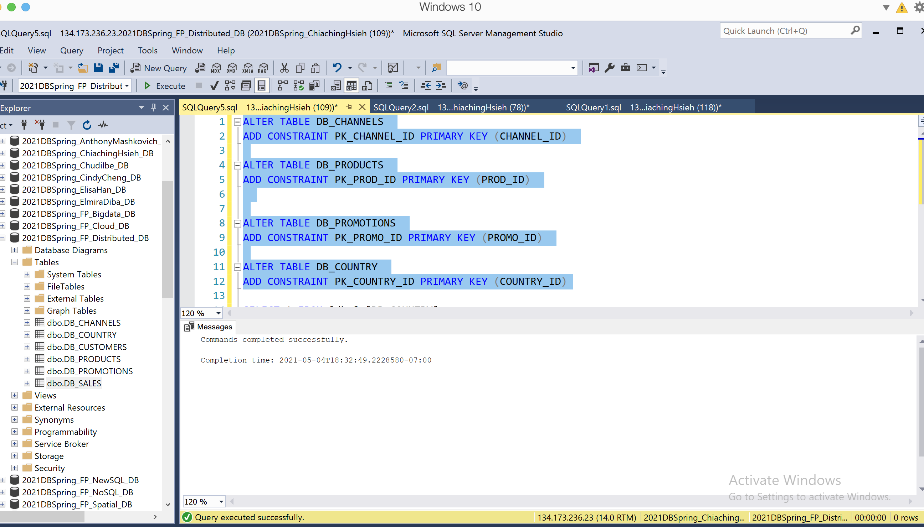

➢ CUSTOMERS:

* Primary Key constraint on CUST_ID
* Foreign Key constraint on COUNTRY_ID
* Domain constraint on CUST_GENDER -- allow only M/F/O (male, female, other)

ALTER TABLE DB_CUSTOMERS

ADD CONSTRAINT PK_CUST_ID PRIMARY KEY (CUST_ID)

ALTER TABLE DB_CUSTOMERS

ADD FOREIGN KEY (COUNTRY_ID) REFERENCES DB_COUNTRY (COUNTRY_ID)

ALTER TABLE DB_CUSTOMERS

ADD CONSTRAINT ckGender CHECK(CUST_GENDER= 'M' OR CUST_GENDER= 'F' OR CUST_GENDER= 'O' )

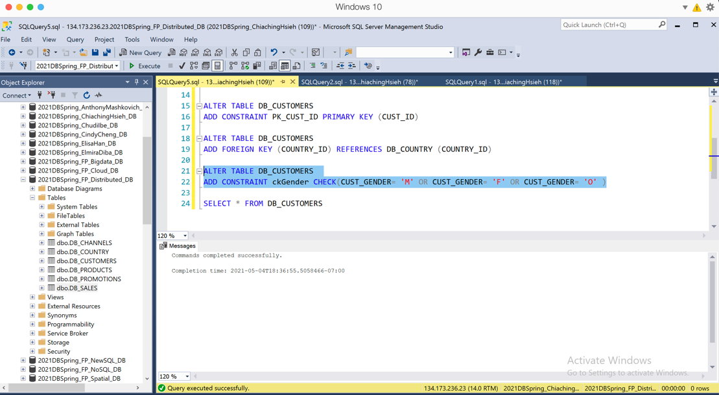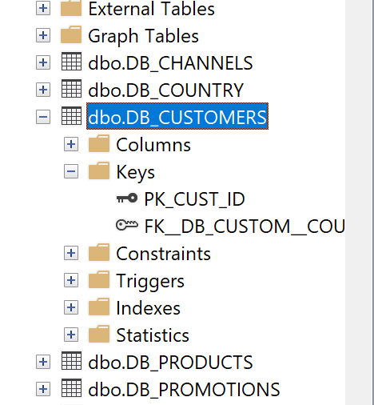

➢ SALES:

* Primary Key constraint on SALESTRANS_ID
* Foreign Key constraint on PROD_ID references PRODUCTS(PROD_ID)
* Foreign Key constraint on CUST_ID references CUSTOMERS(CUST_ID)
* Foreign Key constraint on CHANNEL_ID references CHANNELS(CHANNEL_ID)
* Foreign Key constraint on PROMO_ID references PROMOTIONS(PROMO_ID)

ALTER TABLE DB_SALES---- This is the combined orders table

ADD CONSTRAINT PK_SALESTRANS_ID PRIMARY KEY (SALESTRANS_ID)

ALTER TABLE DB_SALES

ADD FOREIGN KEY (PROD_ID) REFERENCES DB_PRODUCTS (PROD_ID)

ALTER TABLE DB_SALES

ADD FOREIGN KEY (CUST_ID) REFERENCES DB_CUSTOMERS (CUST_ID)

ALTER TABLE DB_SALES

ADD FOREIGN KEY (CHANNEL_ID) REFERENCES DB_CHANNELS (CHANNEL_ID)

ALTER TABLE DB_SALES

ADD FOREIGN KEY (PROMO_ID) REFERENCES DB_PROMOTIONS (PROMO_ID)

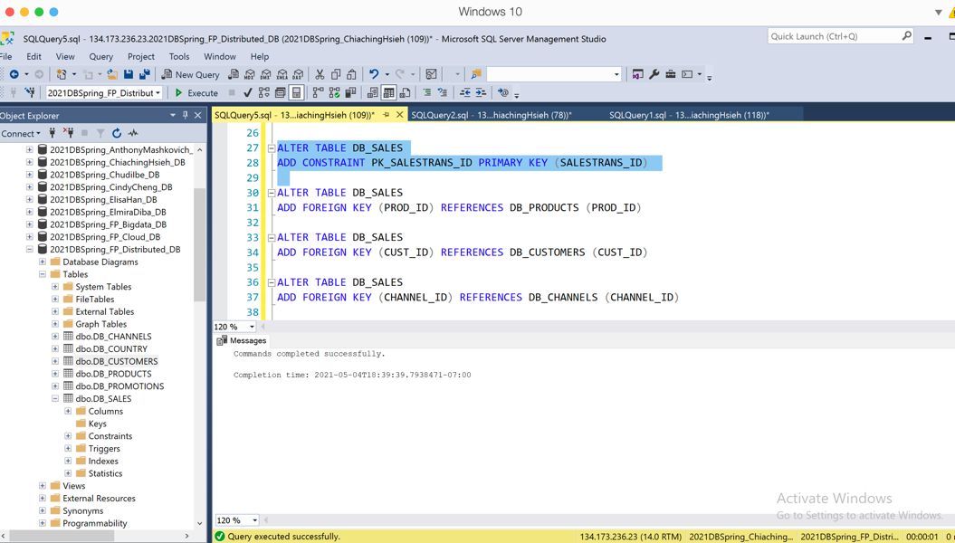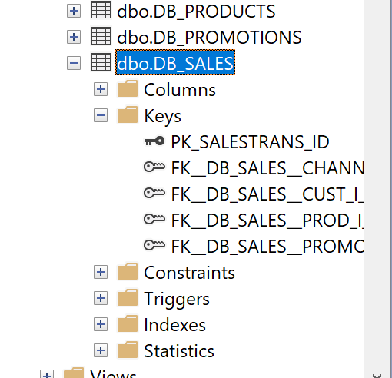

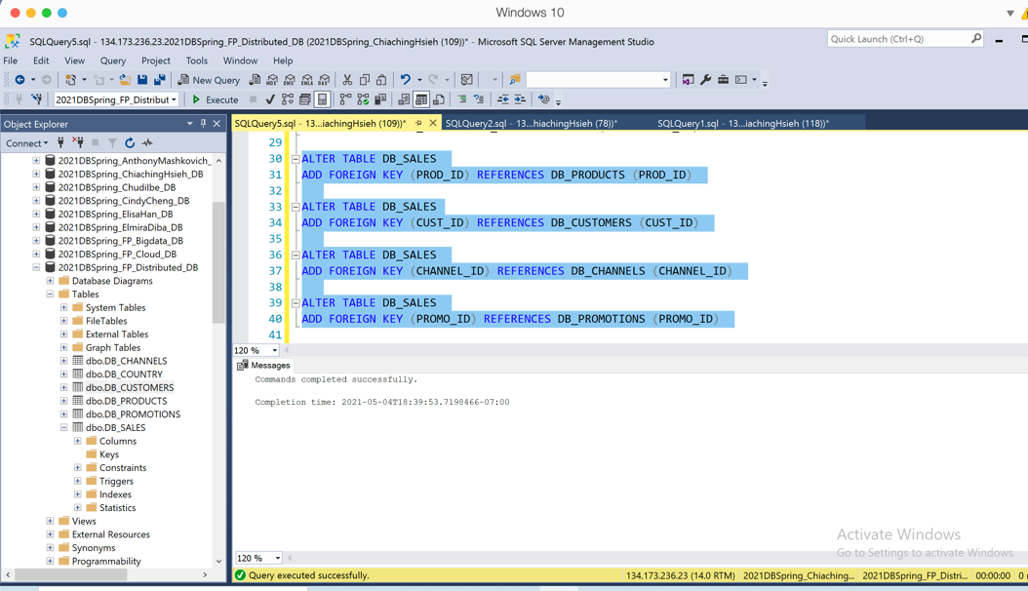

**Section 6 - Physical Design**

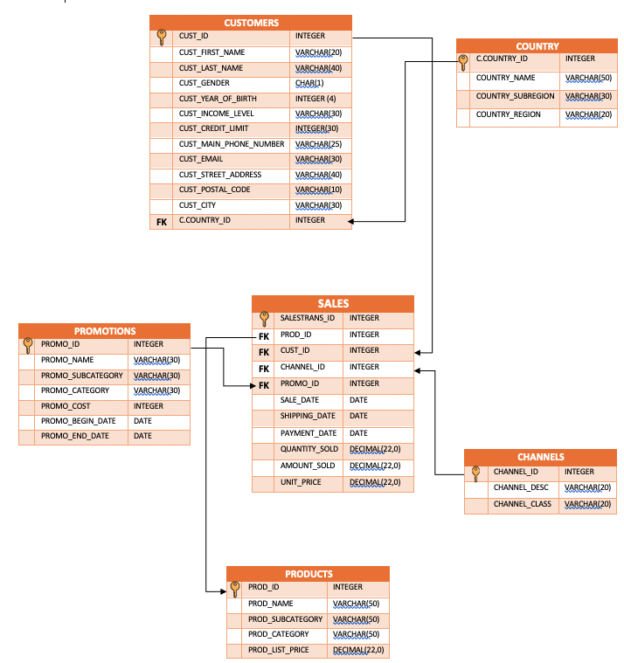

**CREATE TABLE**

--CREATE TABLE DB_CHANNELS

(CHANNEL_ID INT NOT NULL,

CHANNEL_DESC VARCHAR(20) NOT NULL,

CHANNEL_CLASS VARCHAR(20))

--CREATE TABLE DB_PRODUCTS

(PROD_ID INT NOT NULL,

PROD_NAME VARCHAR(50) NOT NULL,

PROMO_DESC VARCHAR(4000) NOT NULL,

PROD_LIST_PRICE DECIMAL(8,2) NOT NULL,

PROD_CATEGORY VARCHAR(50) NOT NULL,

PROD_SUBCATEGORY VARCHAR(50) NOT NULL,

SUPPLIER_ID INT NOT NULL,

PROD_STATUS VARCHAR(20),

)

--CREATE TABLE DB_PROMOTIONS

(PROMO_ID INT NOT NULL,

PROMO_NAME VARCHAR(30) NOT NULL,

PROMO_SUBCATEGORY VARCHAR(30) NOT NULL,

PROMO_CATEGORY VARCHAR(30) NOT NULL,

PROMO_COST NUMERIC NOT NULL,

PROMO_BEGIN_DATE DATE NOT NULL,

PROMO_END_DATE DATE NOT NULL)

--CREATE TABLE DB_COUNTRY

(COUNTRY_ID INT,

COUNTRY_NAME VARCHAR(50),

COUNTRY_SUBREGION VARCHAR(30),

COUNTRY_REGION VARCHAR(20))

--CREATE TABLE DB_CUSTOMERS

(CUST_ID INT,

CUST_FIRST_NAME VARCHAR(20),

CUST_LAST_NAME VARCHAR(40),

CUST_GENDER CHAR(1),

CUST_YEAR_OF_BIRTH DECIMAL(20,0),

CUST_MARITAL_STATUS VARCHAR(20),

CUST_INCOME_LEVEL VARCHAR(30),

CUST_CREDIT_LIMIT DECIMAL(20,2),

CUST_MAIN_PHONE_NUMBER VARCHAR(25),

CUST_EMAIL VARCHAR(30),

CUST_STREET_ADDRESS VARCHAR(40),

CUST_POSTAL_CODE VARCHAR(10),

CUST_STATE_PROVINCE VARCHAR(40),

CUST_CITY VARCHAR(30),

COUNTRY_ID INT,

)

--CREATE TABLE DB_SALES

(SALESTRANS_ID INT NOT NULL,

PROD_ID INT NOT NULL,

CUST_ID INT,

CHANNEL_ID INT NOT NULL,

PROMO_ID INT NOT NULL,

SALE_DATE DATE,

SHIPPING_DATE DATE,

PAYMENT_DATE DATE,

QUANTITY_SOLD INT,

UNIT_PRICE INT,

AMOUNT_SOLD INT)

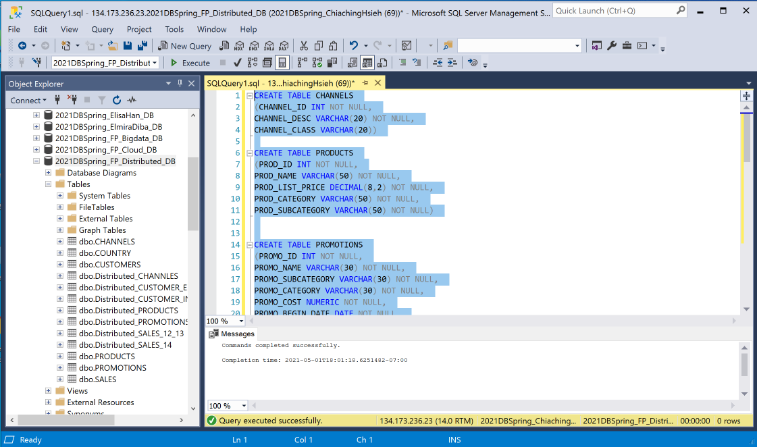

**INSERT STATEMENTS**

--INSERT INTO DB_CHANNELS (CHANNEL_ID, CHANNEL_DESC, CHANNEL_CLASS)

SELECT DISTINCT CHANNEL_ID, CHANNEL_DESC, CHANNEL_CLASS FROM [LIY26].[dbo].[LI_CHANNELS]

--INSERT INTO DB_PRODUCTS (PROD_ID, PROD_NAME, PROD_LIST_PRICE, PROD_CATEGORY,

PROD_SUBCATEGORY)

SELECT DISTINCT PROD_ID, PROD_NAME, PROD_LIST_PRICE, PROD_CATEGORY, PROD_SUBCATEGORY

FROM [LIY26].[dbo].[LI_PRODUCTS]

--INSERT INTO DB_PROMOTIONS (PROMO_ID, PROMO_NAME, PROMO_SUBCATEGORY,

PROMO_CATEGORY, PROMO_COST, PROMO_BEGIN_DATE, PROMO_END_DATE)

SELECT DISTINCT PROMO_ID, PROMO_NAME, PROMO_SUBCATEGORY, PROMO_CATEGORY,

PROMO_COST, PROMO_BEGIN_DATE, PROMO_END_DATE

FROM [LIY26].[dbo].[LI_PROMOTIONS]

--INSERT INTO DB_COUNTRY (COUNTRY_ID, COUNTRY_NAME, COUNTRY_SUBREGION, COUNTRY_REGION)

SELECT DISTINCT COUNTRY_ID, COUNTRY_NAME, COUNTRY_SUBREGION, COUNTRY_REGION

FROM [LIY26].[dbo].[LI_CUSTOMERS_INTX]

--INSERT INTO DB_CUSTOMERS

SELECT N.CUST_ID, N.CUST_FIRST_NAME, N.CUST_LAST_NAME, N.CUST_GENDER, E.CUST_YEAR_OF_BIRTH,E.CUST_INCOME_LEVEL, E.CUST_CREDIT_LIMIT,N.CUST_MAIN_PHONE_NUMBER, N.CUST_EMAIL, N.CUST_STREET_ADDRESS,N.CUST_POSTAL_CODE, N.CUST_CITY, N.COUNTRY_ID

FROM [LIY26].[dbo].[LI_CUSTOMERS_INTX] AS N

JOIN [LIY26].[dbo].[LI_CUSTOMERS_EXT] AS E ON N.CUST_ID=E.CUST_ID

--INSERT INTO DB_SALES (SALESTRANS_ID, PROD_ID, CUST_ID, CHANNEL_ID, PROMO_ID,

SALE_DATE, SHIPPING_DATE, PAYMENT_DATE, QUANTITY_SOLD, UNIT_PRICE, AMOUNT_SOLD)

SELECT DISTINCT SALESTRANS_ID, PROD_ID, CUST_ID, CHANNEL_ID, PROMO_ID,

SALE_DATE, SHIPPING_DATE, PAYMENT_DATE, QUANTITY_SOLD, UNIT_PRICE, AMOUNT_SOLD

FROM [LIY26].[dbo].[LI_SALES_12_13]

--INSERT INTO DB_SALES (SALESTRANS_ID, PROD_ID, CUST_ID, CHANNEL_ID, PROMO_ID,

SALE_DATE, SHIPPING_DATE, PAYMENT_DATE, QUANTITY_SOLD, UNIT_PRICE, AMOUNT_SOLD)

SELECT DISTINCT SALESTRANS_ID, PROD_ID, CUST_ID, CHANNEL_ID, PROMO_ID,

SALE_DATE, SHIPPING_DATE, PAYMENT_DATE, QUANTITY_SOLD, UNIT_PRICE, AMOUNT_SOLD

FROM [LIY26].[dbo].[LI_SALES_14]

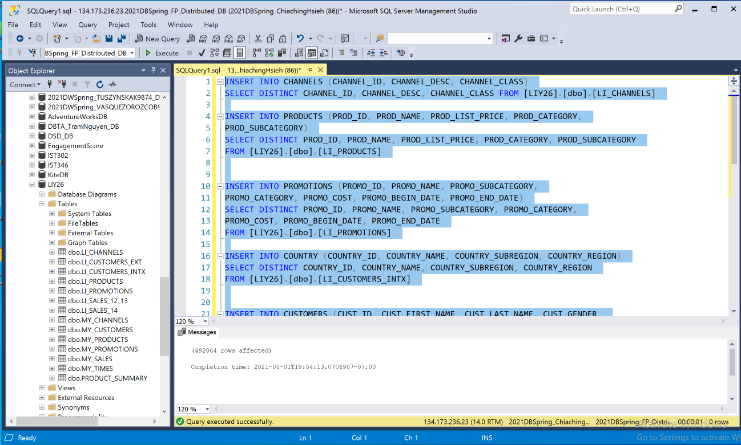

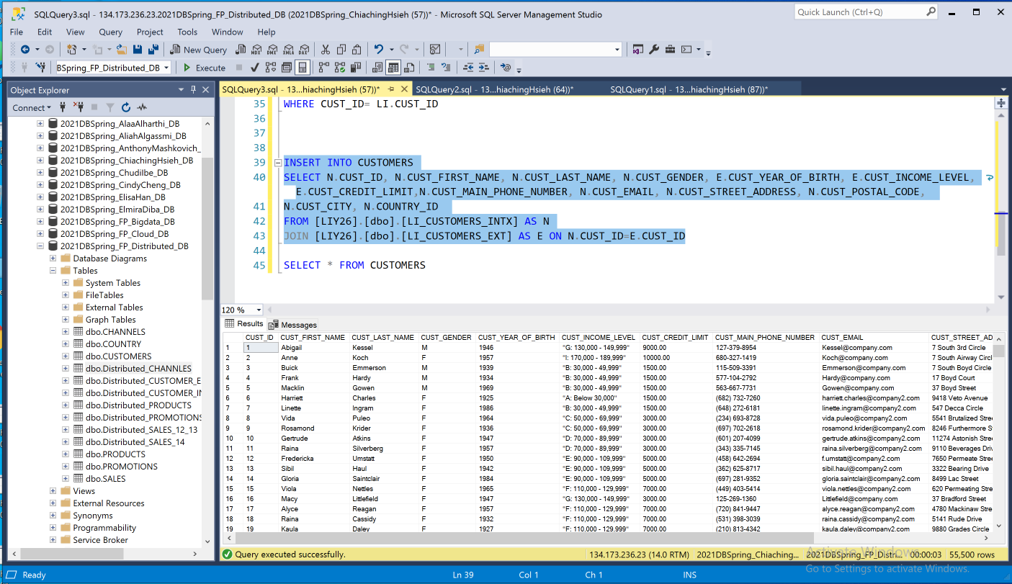

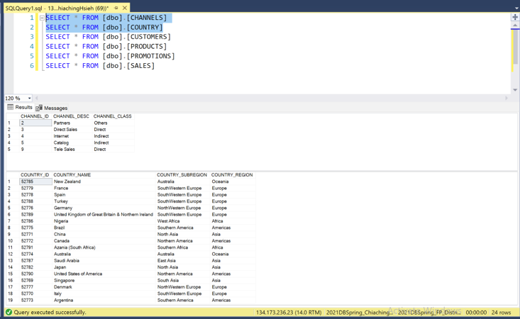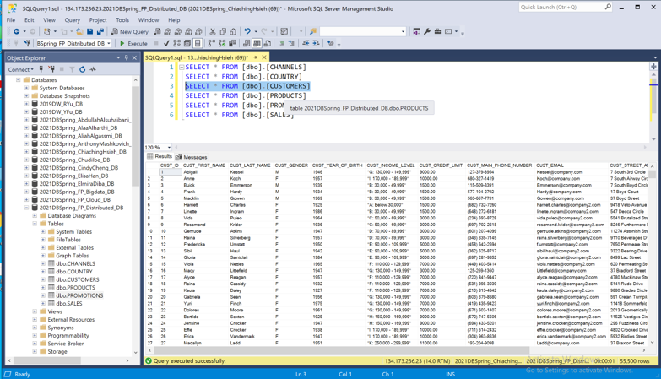

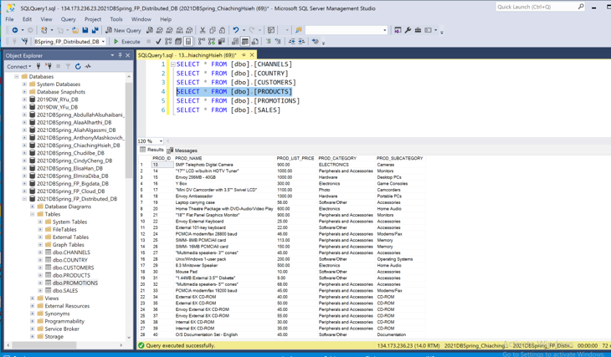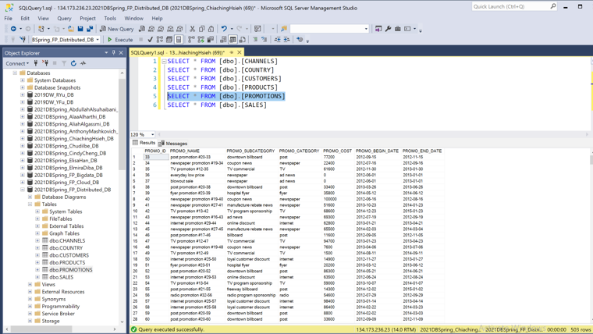

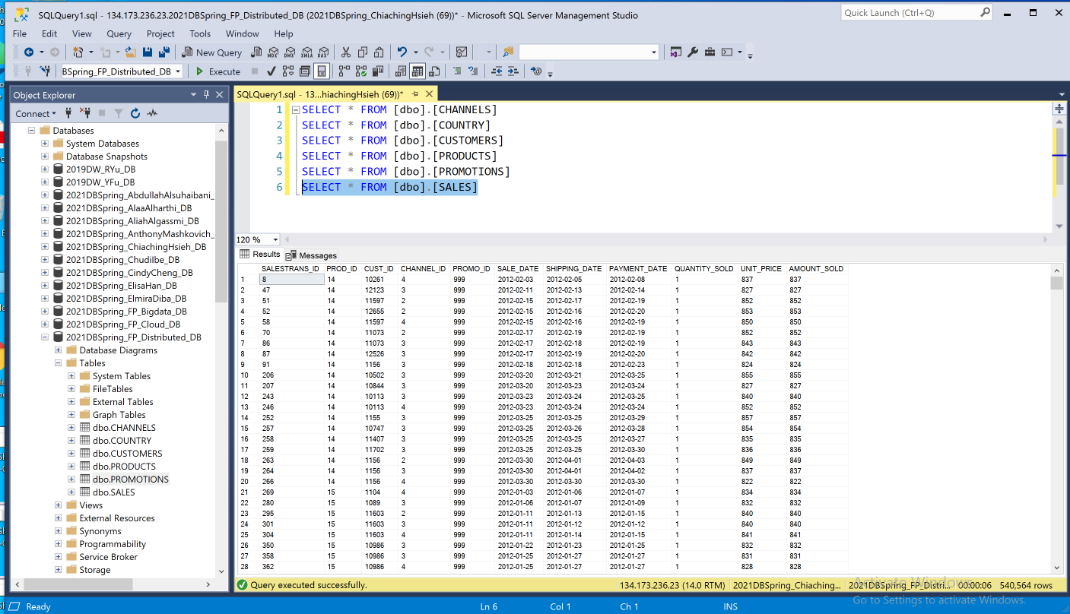

**Section 7: Database Implementation**

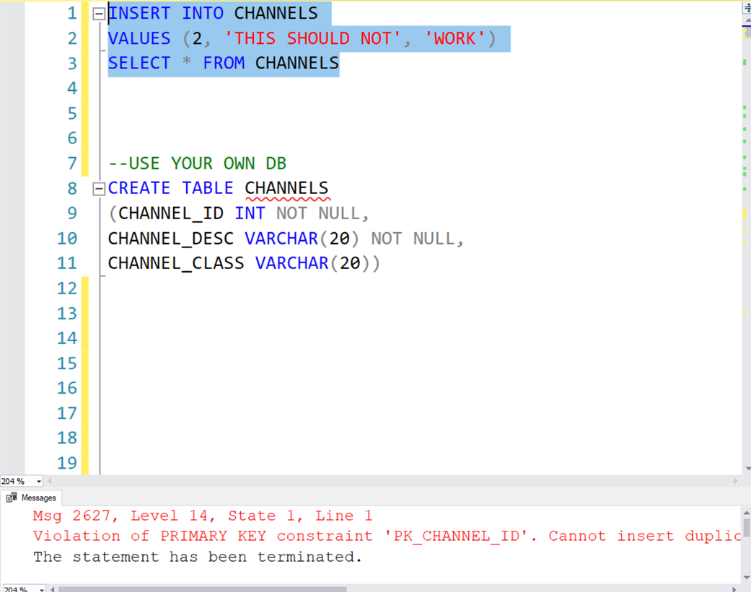

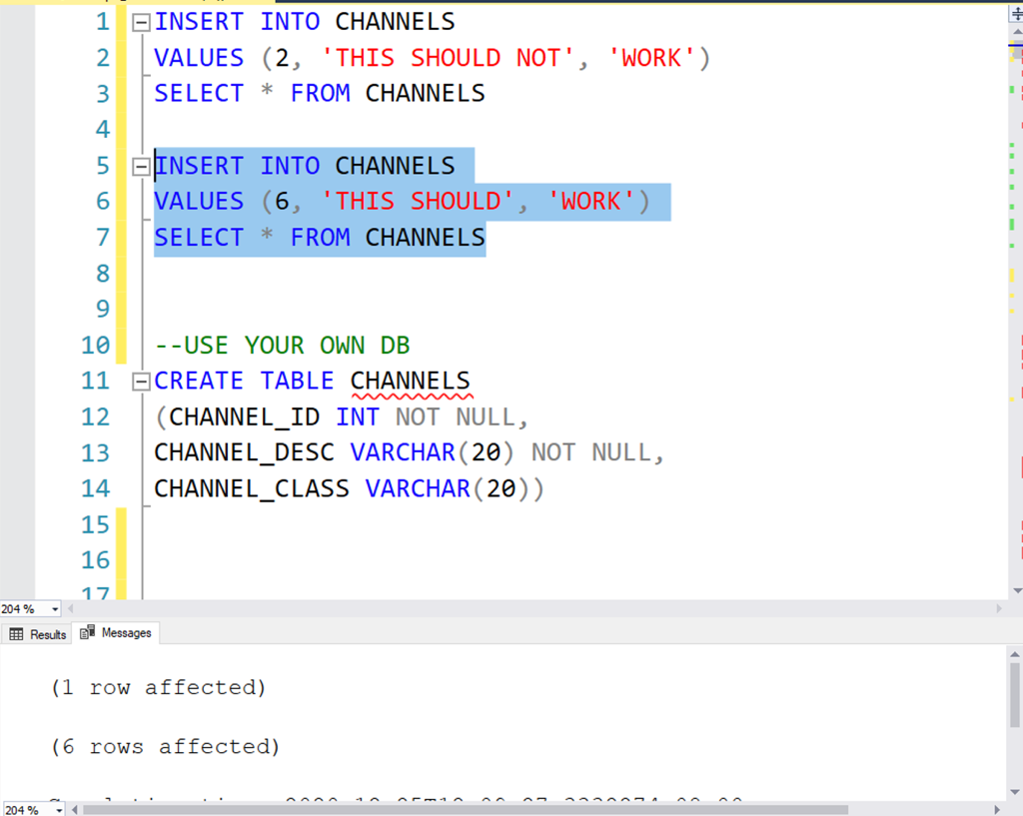

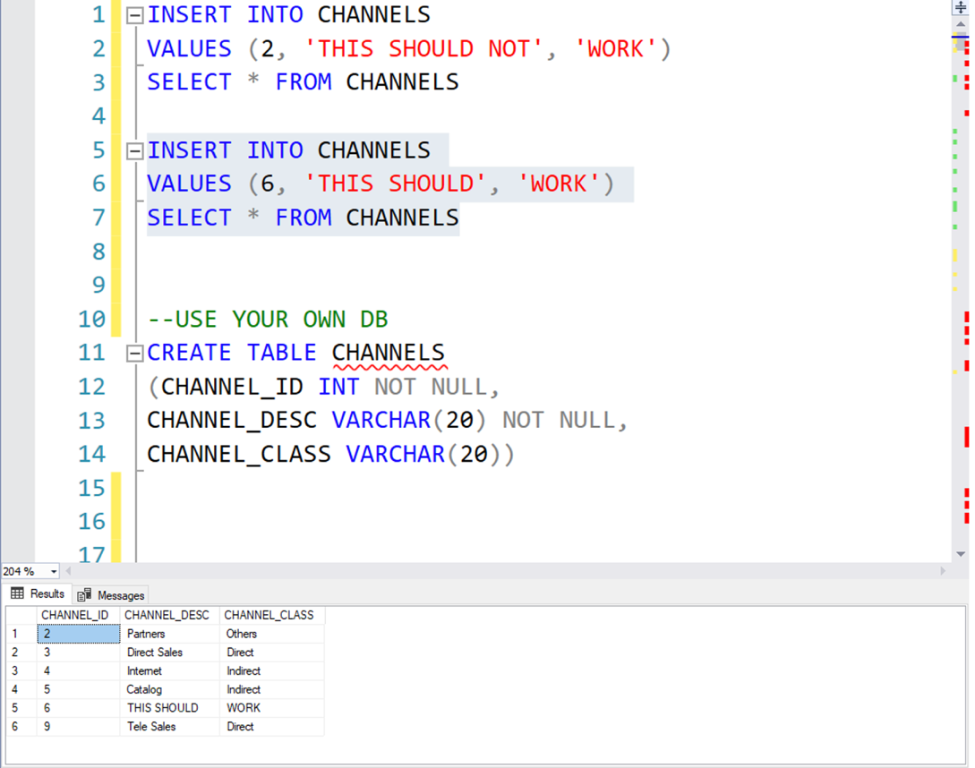

**View BV01**

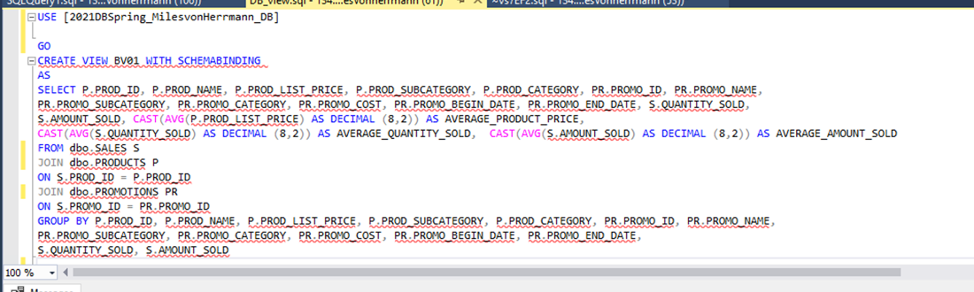

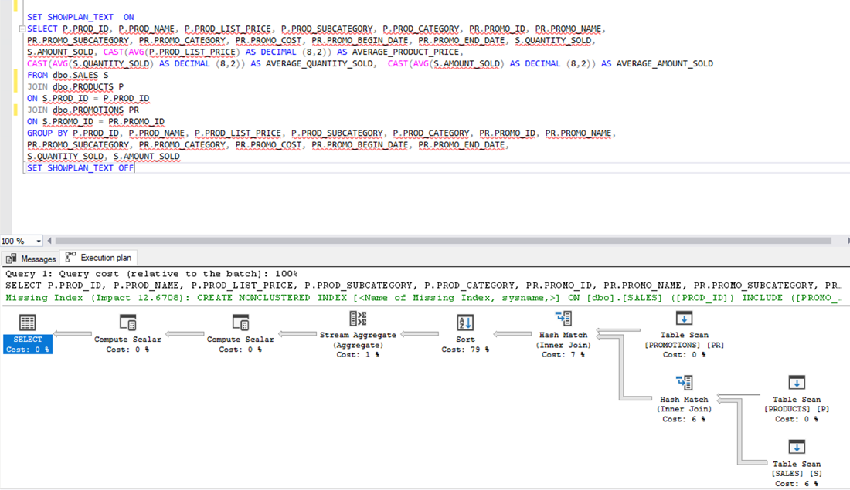

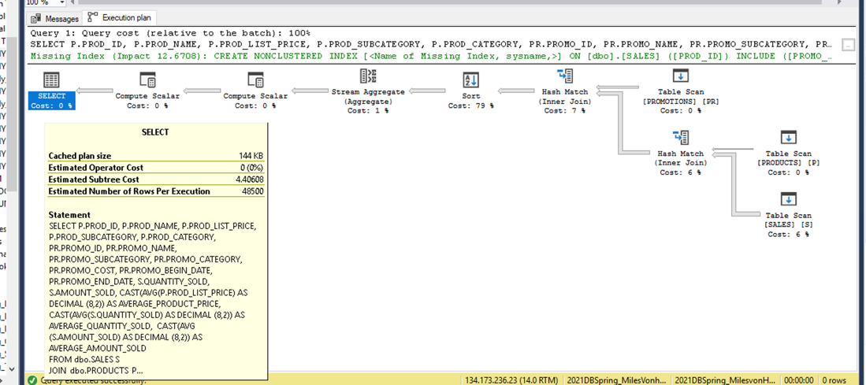

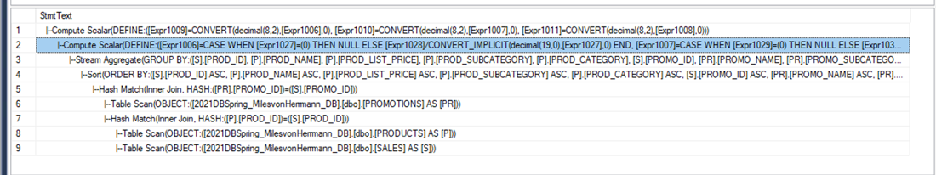

Execution Plan:

1) Table scan performed on table PROMOTIONS

2) Table scan performed on table PRODUCTS

3) Table scan performed on table SALES

**View BV02**

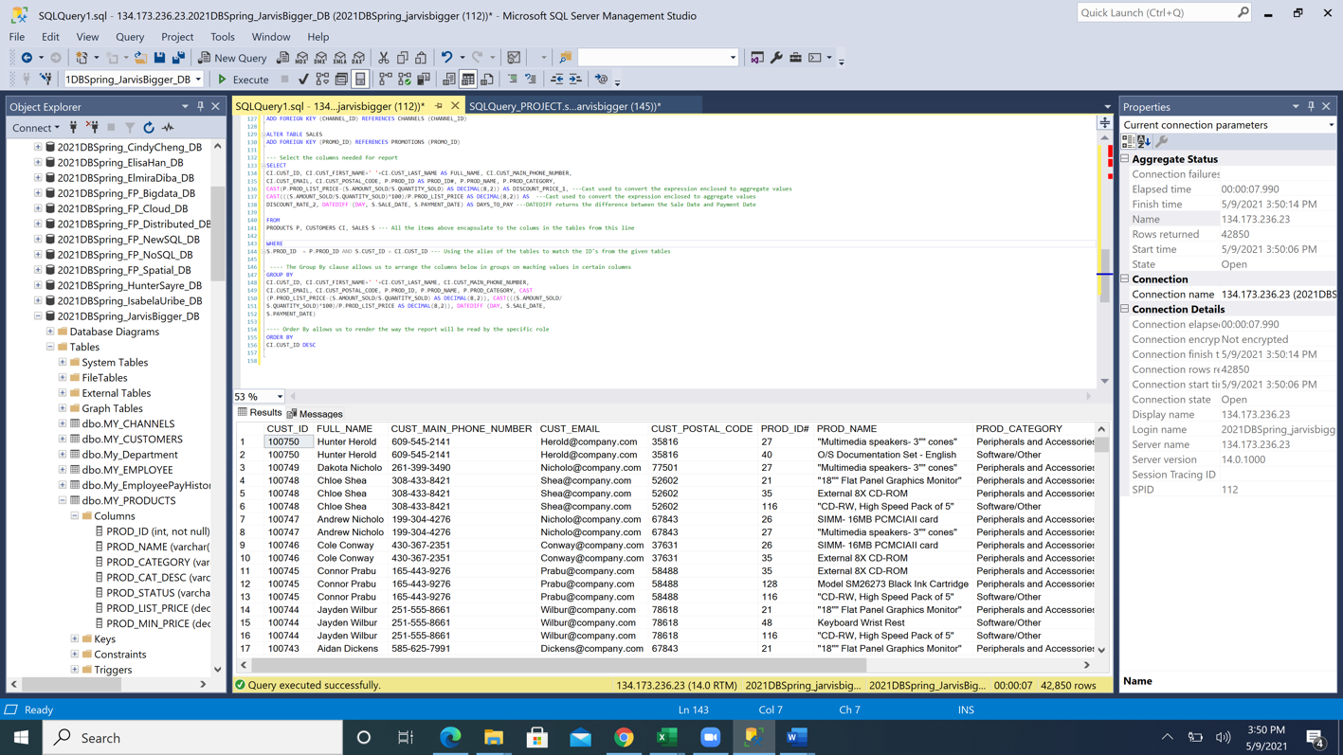

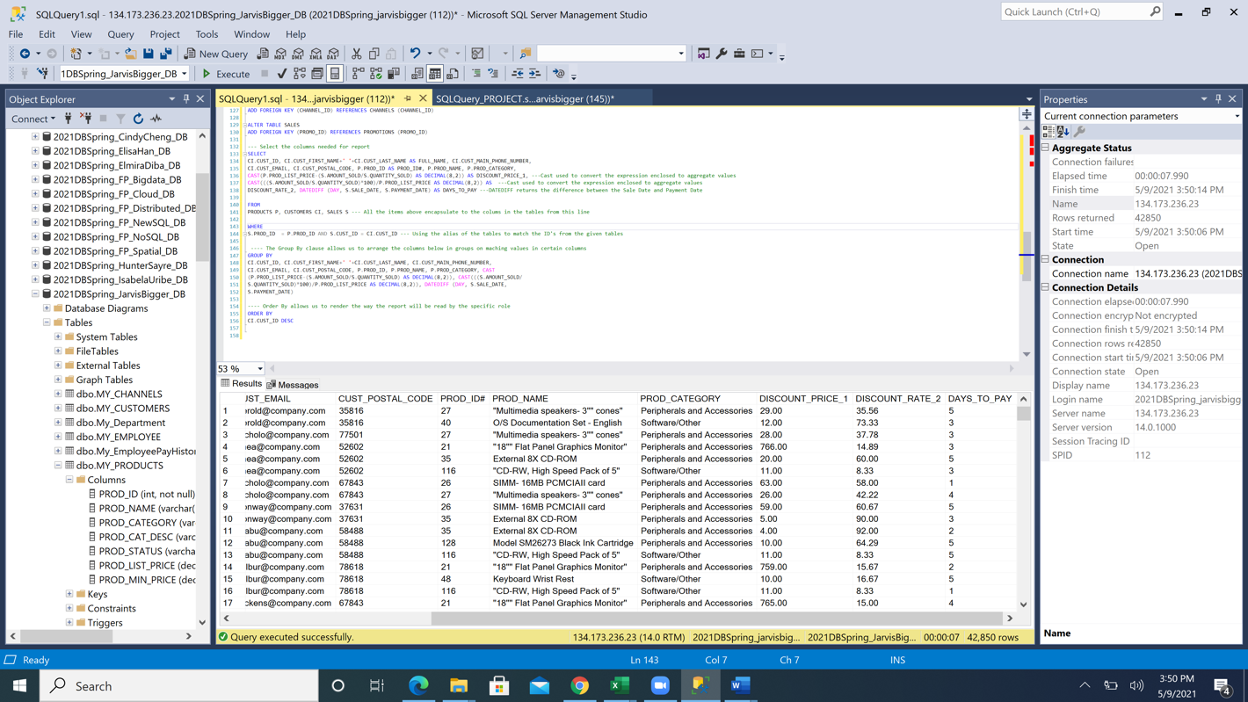

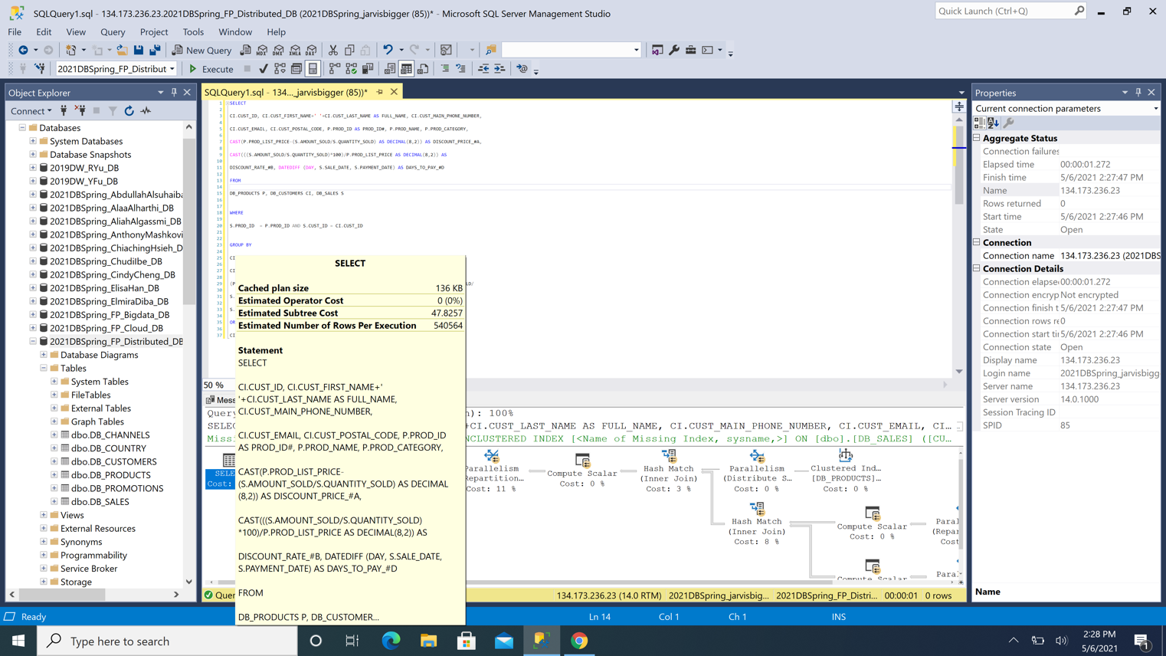

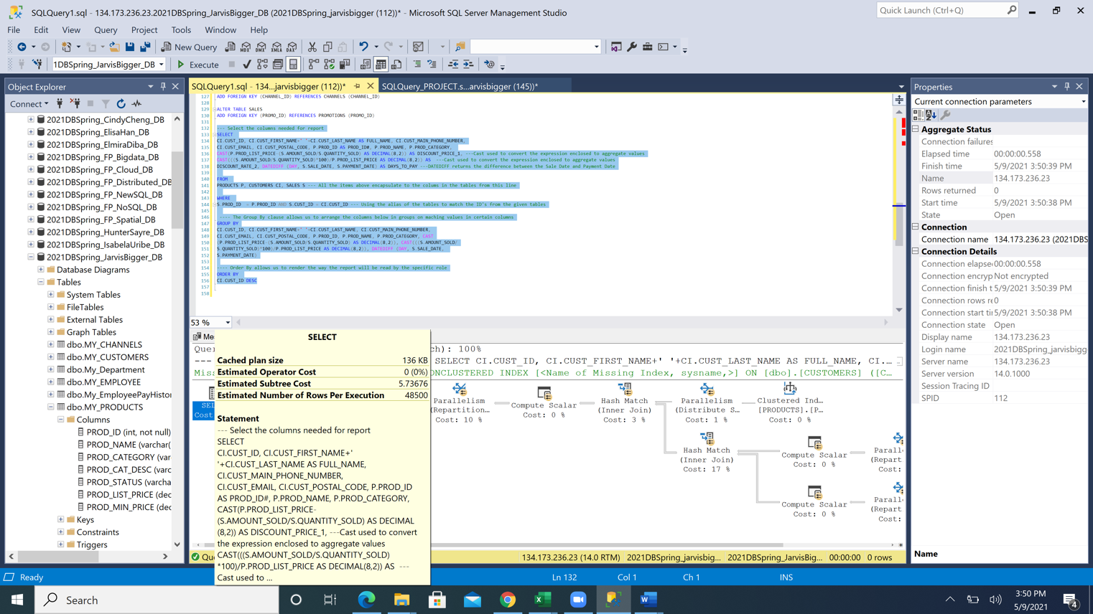

**View BV03**

**Create View PRODUCT_SOLD_GENDER**

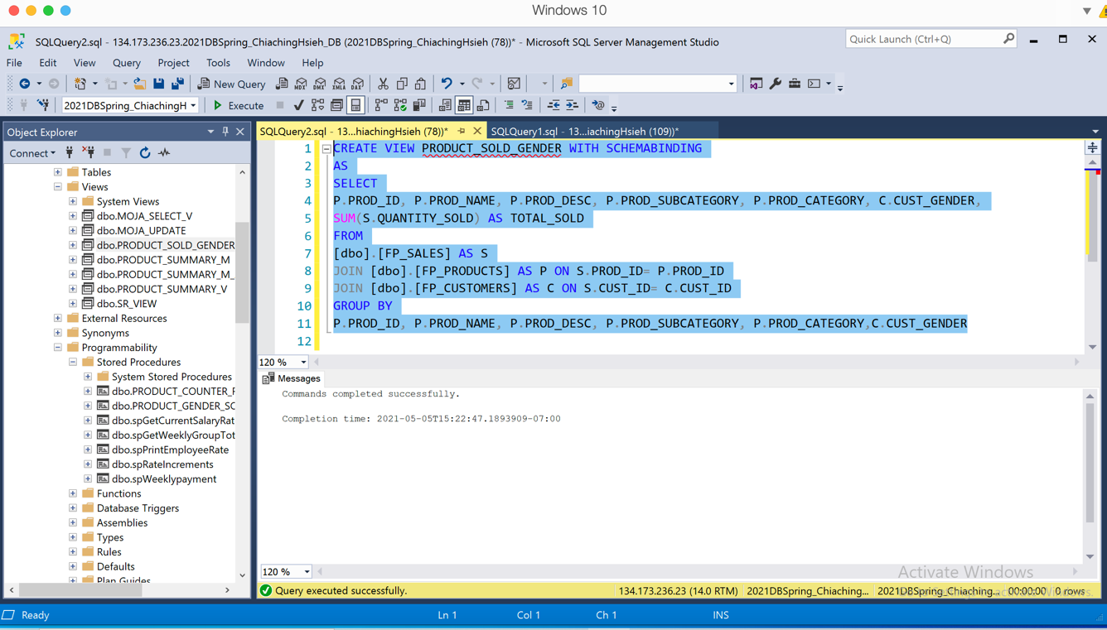

**Result**

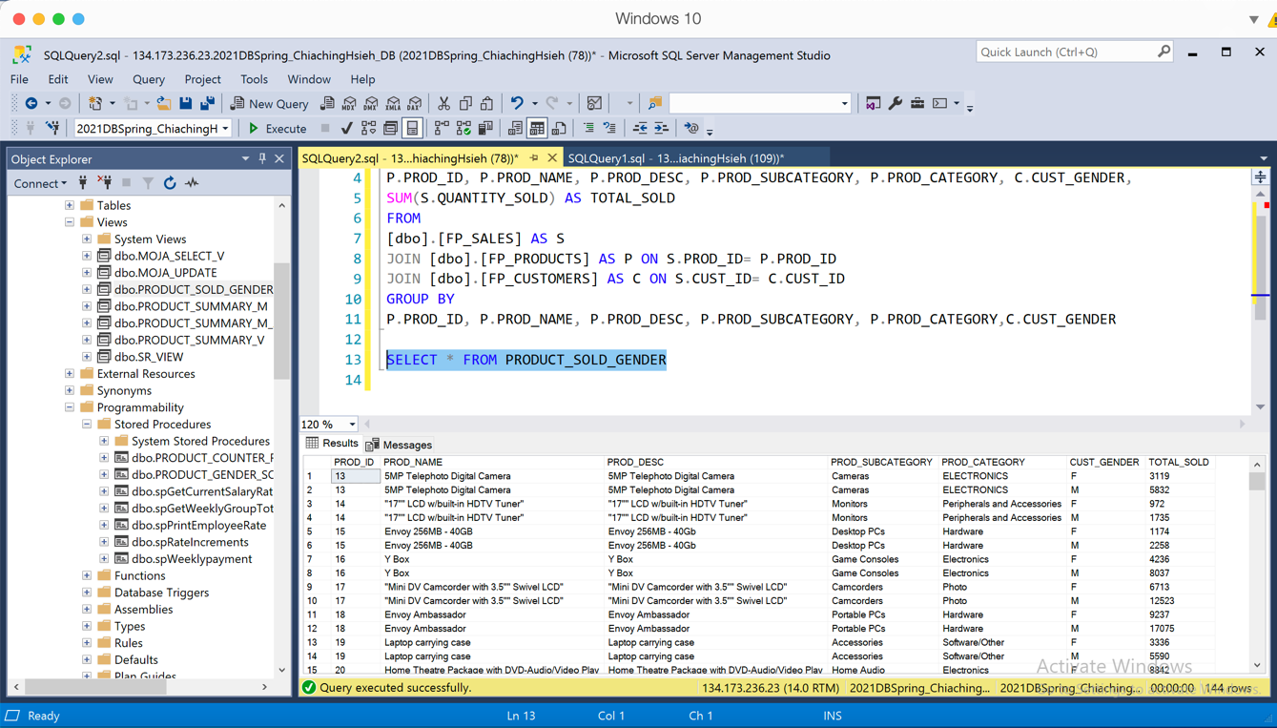

**Create PROC**

**ONE non-view(PRODUCT_GENDER_SOLD)**

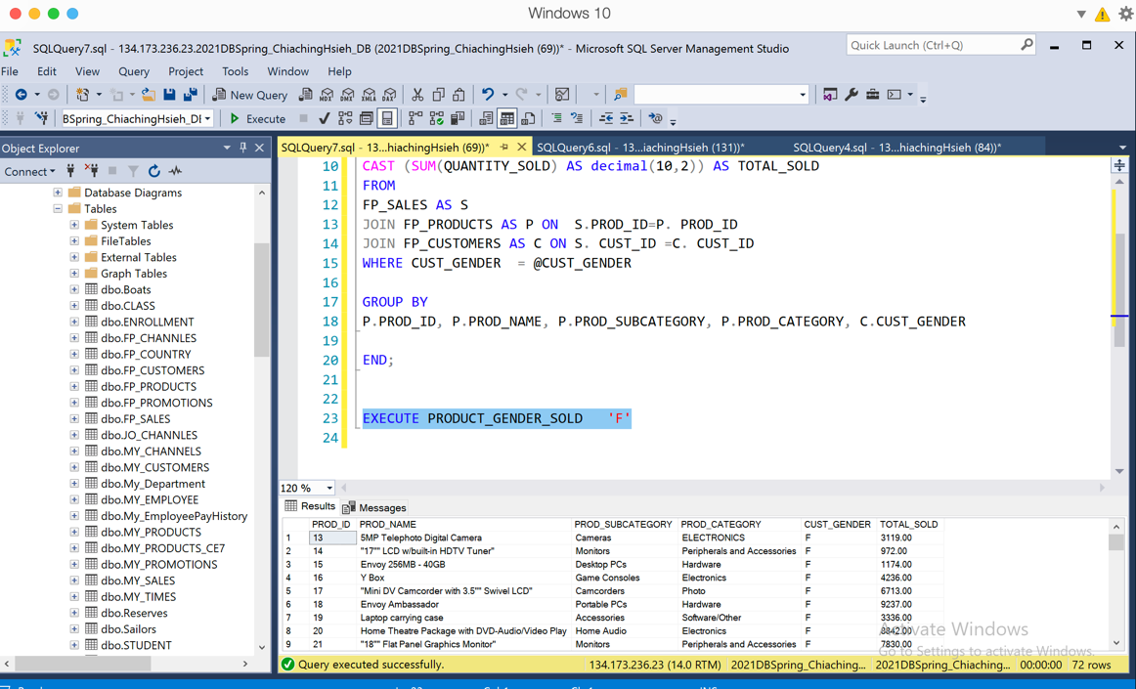

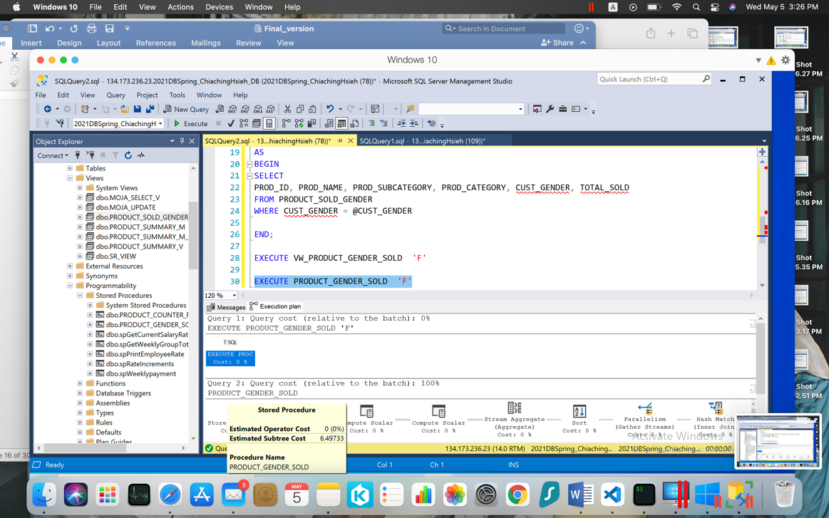

**TWO -view(VW_PRODUCT_GENDER_SOLD)**

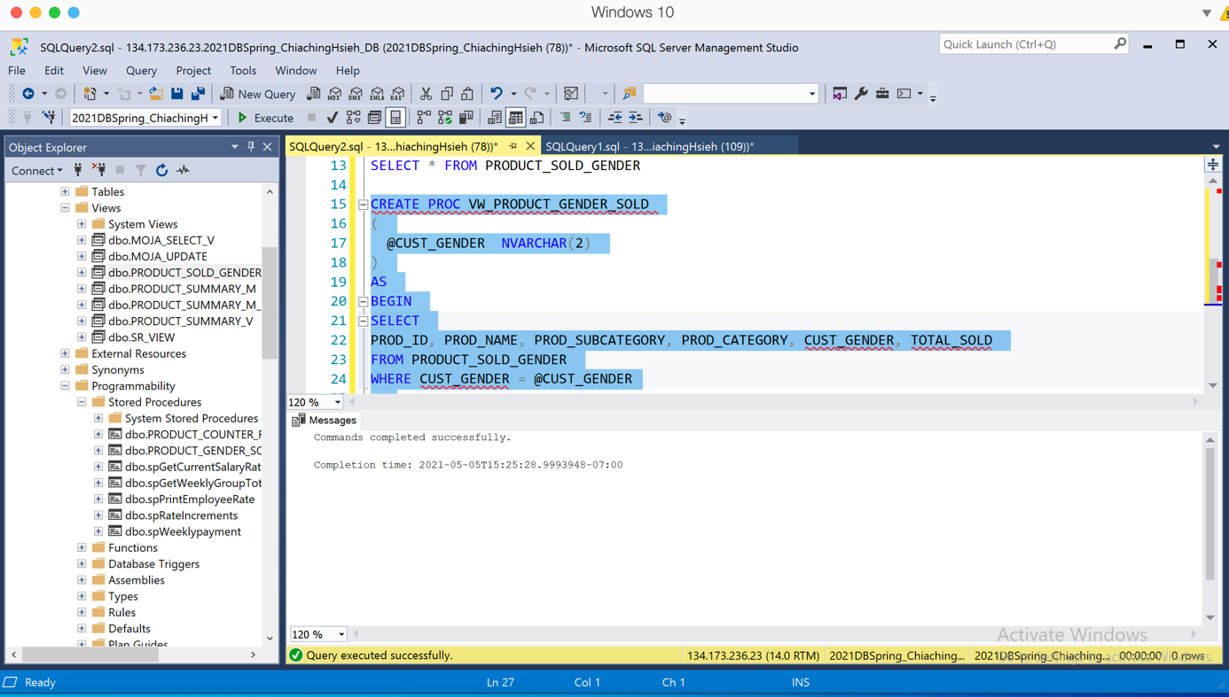

**Result**

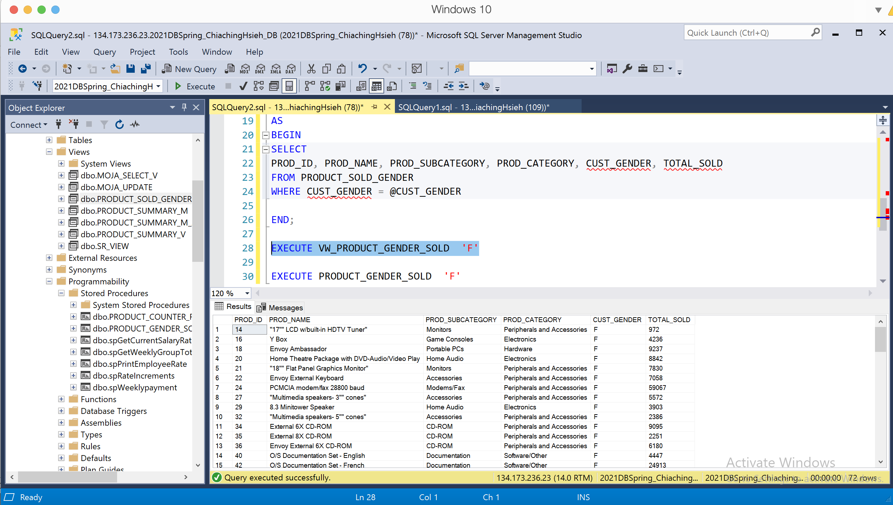

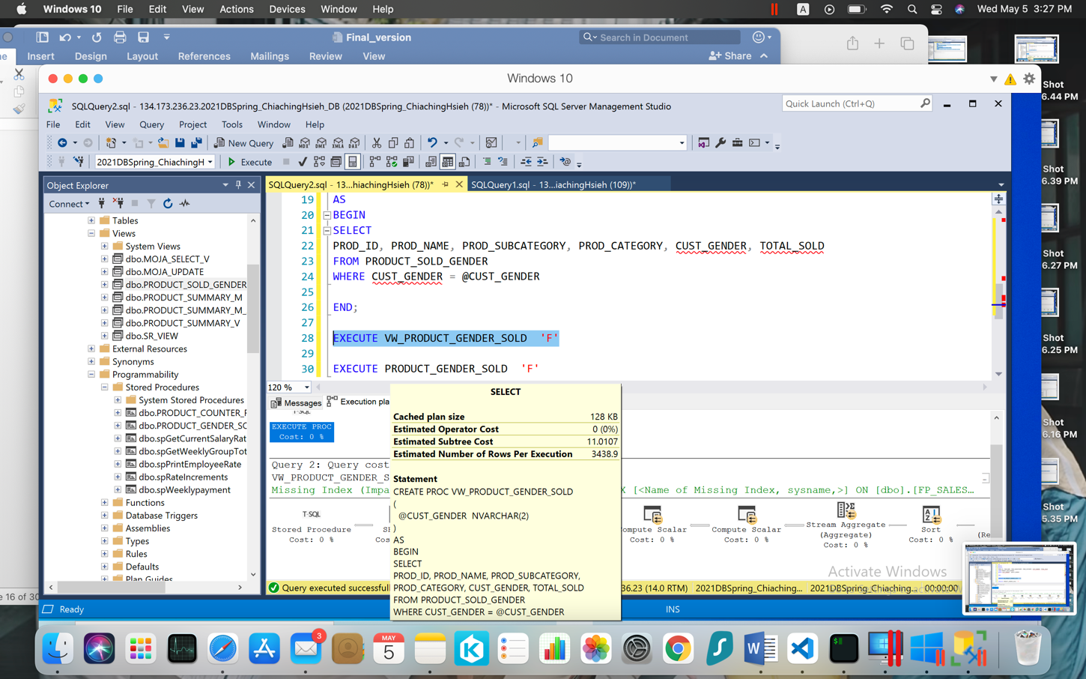

**View BV04**

**Create View PRODUCT_SOLD_CATEGORY**

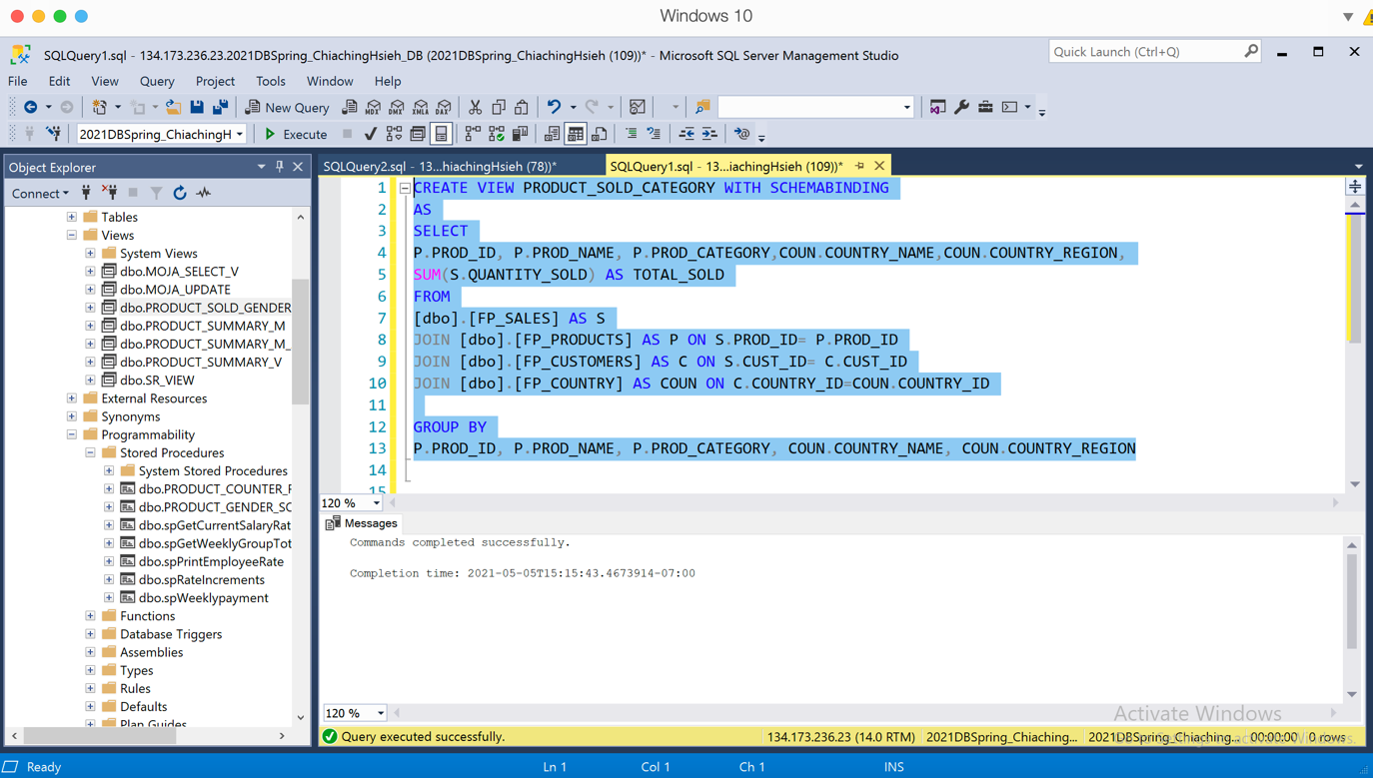

**Result**

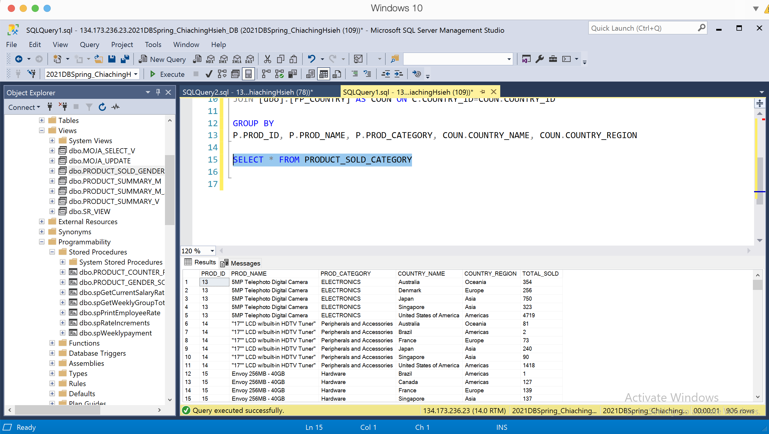

**Create PROC**

**ONE non-view(PRODUCT_COUNTER_REGION_SOLD)**

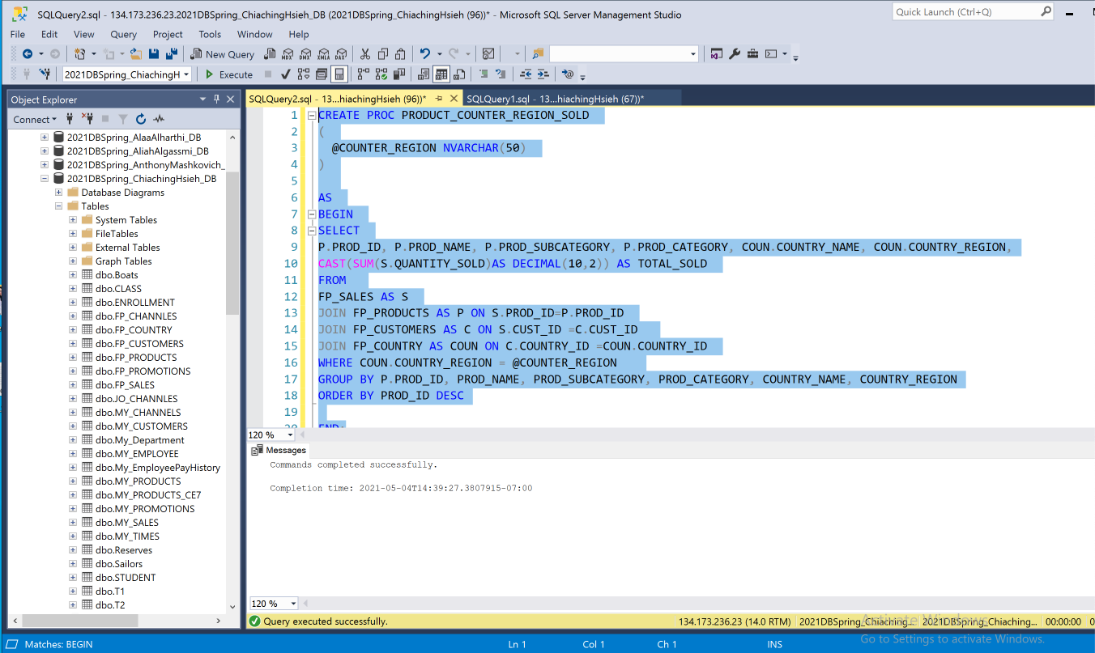

**Result**

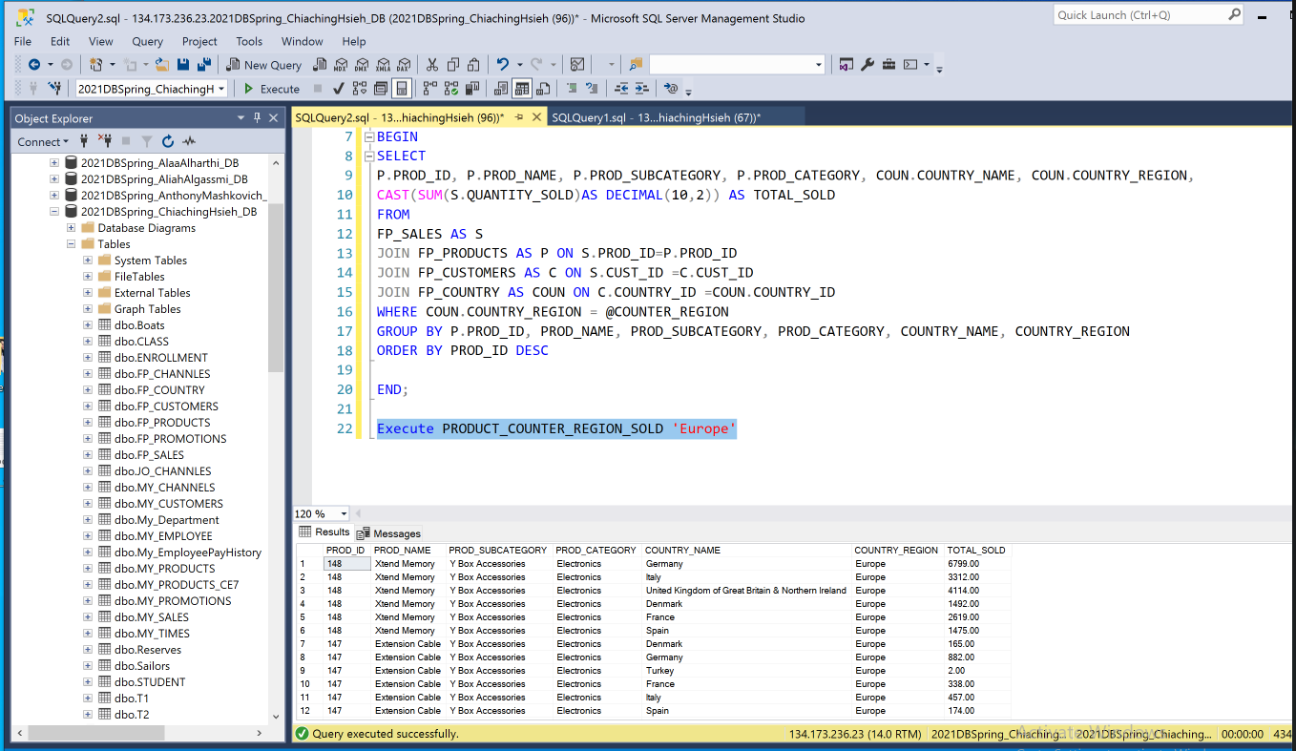

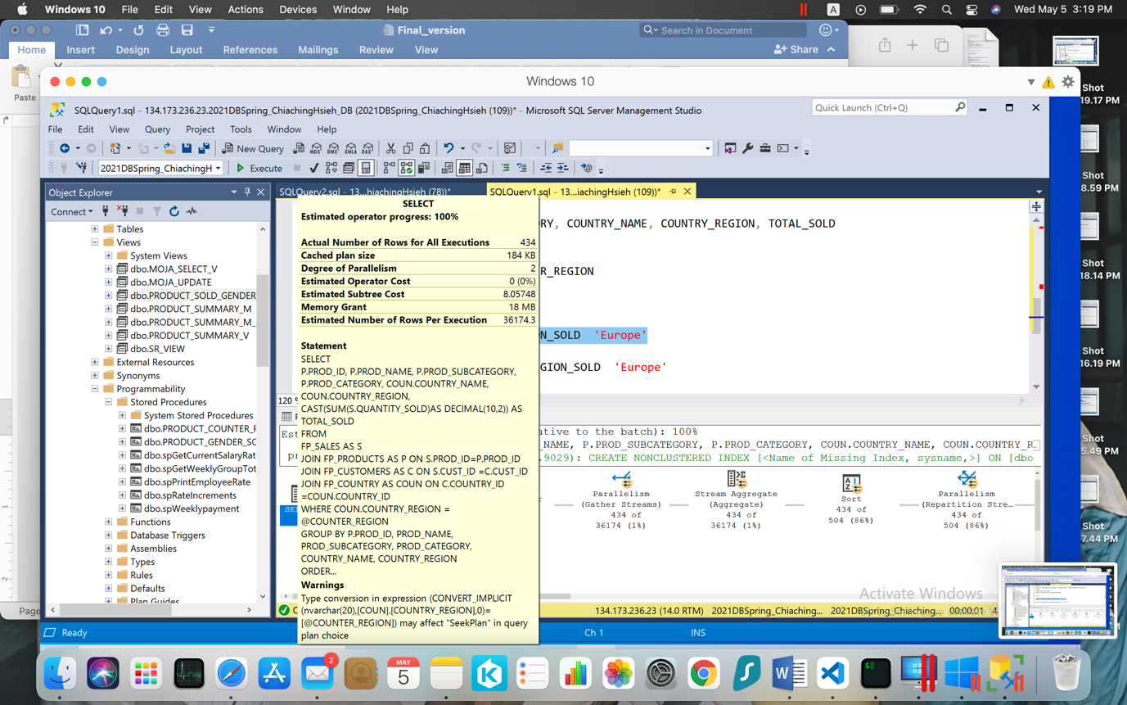

**TWO-view(VW_PRODUCT_COUNTER_REGION_SOLD)**

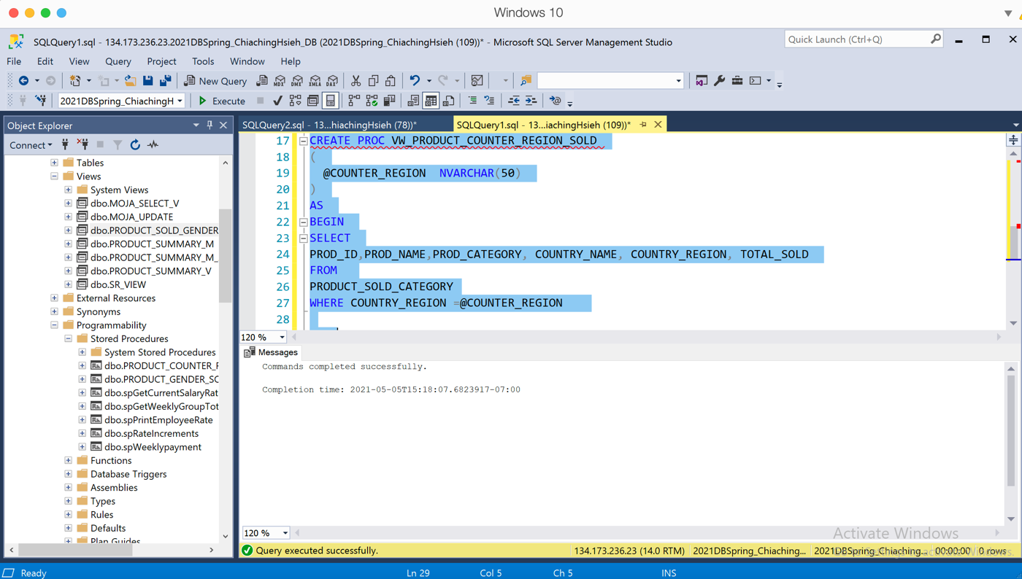

**Result**

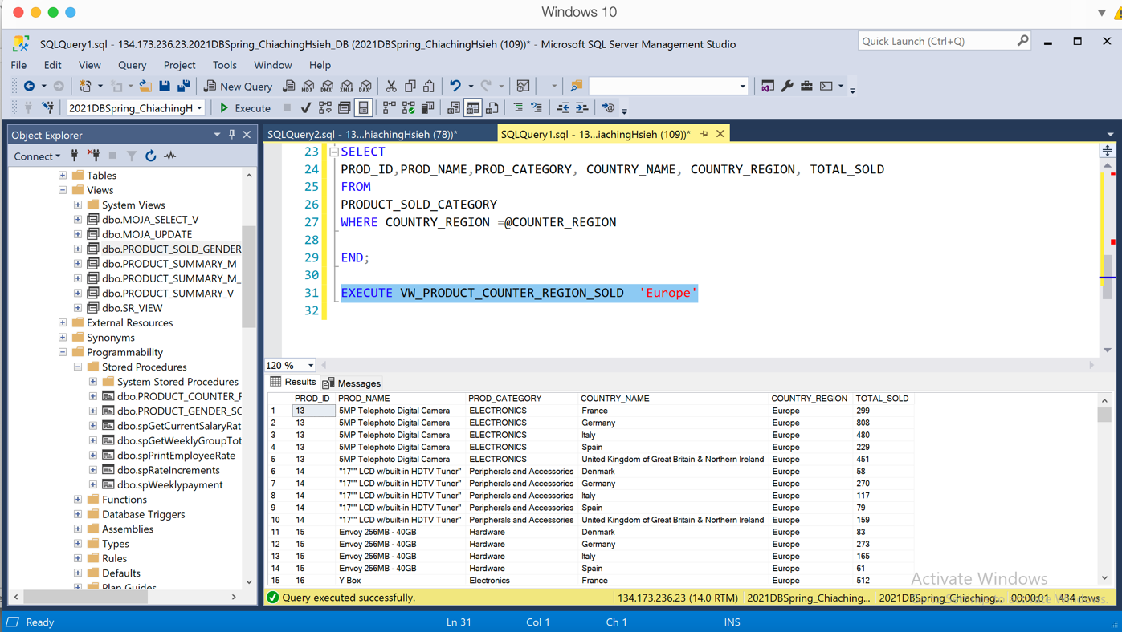

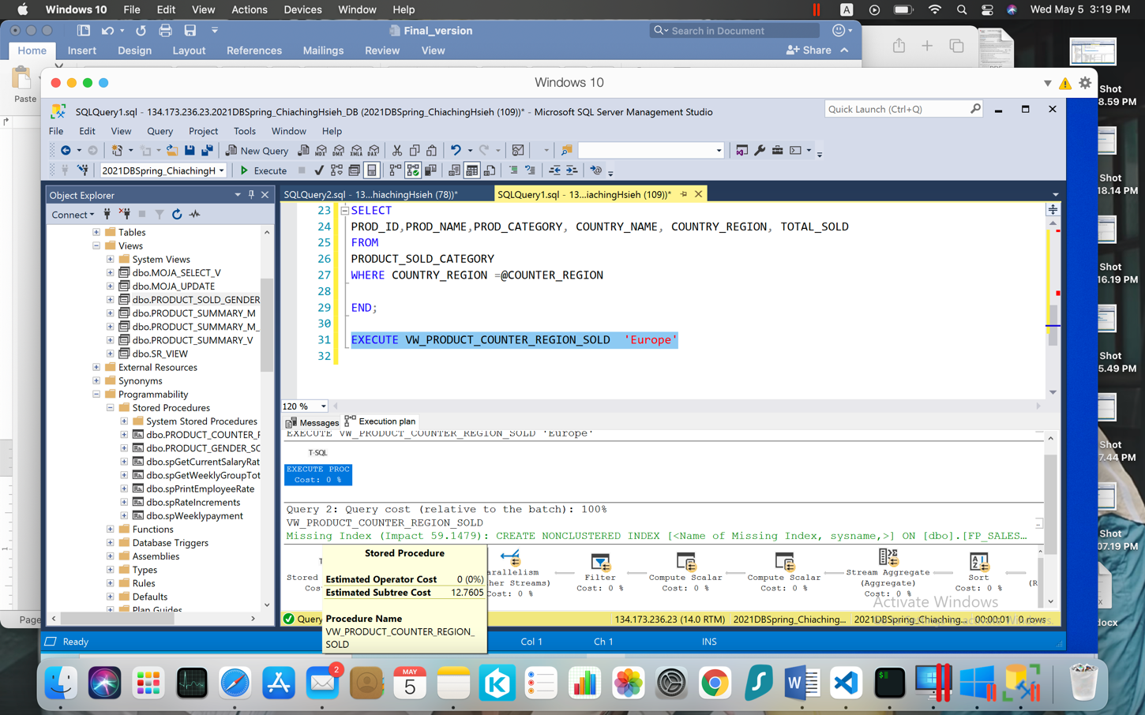

**Section 8: Conclusion**

For this project, we got the experience about the whole process from understanding the client’s requirement, the problem of the database, and data understanding to figure put the model design, solution and make different view to a different position. The main problem which client is facing right now including the database is too slow, the database has too many inconsistencies, and no reports for the business users. Based on the client’s requirement, how to improve the database speed become our main goal for this project.

We separate our focus on the different positions such as Marketing managers, Sales Associates, and Product managers. The different position has different demand and requires for the database, and we can create the constrain on their security privileges. By limiting their access, we can improve the database management and drop down the searching time. We start by analyzing the position transaction details, understanding the old database, and design the structure of the new database by cleaning data and then created a view for each position.

We learned from this project:

* Data come in many different shapes and sizes and symmetrical to a puzzle piece given the customer’s needs. Columns we as consultants thought as useful proved to be valuable to the business, so we never want to assume that our logic is right. Coming to a mutual understanding with the customer to design an efficient database process that will achieve all of their needs.
* Understanding is the most important for database management. There has not right answer in the real world project, same problem can use ten different way to solve. But understand what is the client’s requirement is the best way to make a suitable solution.
* Dependencies within data drive how we interact with data originating from different tables and specify how data can be linked between different tables to generate unique combinations of transaction information details. Primary keys are major signifiers of attribute relationships within tables, and non-primary key attributes help to reveal attribute relationships within a table at a finer level.